AOP-22
Edition 2

NORTH ATLANTIC TREATY ORGANIZATION
(NATO)



NATO STANDARDIZATION AGENCY
(NSA)

STANDARDIZATION AGREEMENT
(STANAG)

SUBJECT: DESIGN CRITERIA AND TEST METHODS FOR INDUCTIVE SETTING OF ELECTRONIC PROJECTILE FUZES

Promulgated on

Jan H ERIKSEN
Rear Admiral, NONA
Director, NSA

RECORD OF AMENDMENTS

No. | Reference/date of  amendment | Date  entered | Signature

EXPLANATORY NOTES
AGREEMENT

1. This NATO Standardization Agreement (STANAG) is promulgated by the Director, NSA under the authority vested in him by the NATO Military Committee.

2. No departure may be made from the agreement without consultation with the tasking authority. Nations may propose changes at any time to the tasking authority where they will be processed in the same manner as the original agreement.

3. Ratifying nations have agreed that national orders, manuals and instructions implementing this STANAG will include a reference to the STANAG number for purposes of identification.

DEFINITIONS

4. Ratification is "In NATO Standardization, the fulfilment by which a member nation formally accepts, with or without reservation, the content of a Standardization Agreement" (AAP-6).

5. Implementation is "In NATO Standardization, the fulfilment by a member nation of its obligations as specified in a Standardization Agreement" (AAP-6).

6. Reservation is "In NATO Standardization, the stated qualification by a member nation that describes the part of a Standardization Agreement that it will not implement or will implement only with limitations" (AAP-6).

RATIFICATION, IMPLEMENTATION AND RESERVATIONS

7. Page (iii) gives the details of ratification and implementation of this agreement. If no details are shown it signifies that the nation has not yet notified the tasking authority of its intentions. Page (iv) (and subsequent) gives details of reservations and proprietary rights that have been stated.

FEEDBACK

8. Any comments concerning this publication should be directed to NATO/NSA - Bvd Leopold III, 1110 Brussels - BE.

RATIFICATION AND IMPLEMENTATION DETAILS
STADE DE RATIFICATION ET DE MISE EN APPLICATION

* See overleaf reservations(*)/comments (+)
Voir au verso réserves (*)/commentaires (+)

RESERVES/RESERVATIONS

COMMENTS/COMMENTAIRES

NAVY/ARMY/AIR

ALLIED ORDNANCE PUBLICATION
(AOP)

DESIGN CRITERIA AND TEST METHODS FOR INDUCTIVE SETTING OF ELECTRONIC PROJECTILE FUZES

Annexes:
A - Definitions and Abbreviations
B - Setter Development Test Procedure
C - Fuze Development Test Procedure
D - U.S. Navy setter and fuze-specific parameters
E - Registered Fuze Identification Codes and Messages

Related Documents:

- STANAG 4369, Design Requirements for Inductive
Setting of Large Calibre Electronic Projectile Fuzes.
- STANAG 2916, Nose Fuze Contours and Matching
Projectile Cavities for Artillery and Mortar Projectiles.

AIM

1. The aim of this AOP is to provide details in support of STANAG 4369 in order to achieve interoperability among the NATO forces in the setting of inductively settable projectile fuzes. This AOP establishes the detailed requirements for the characteristics of new ordnance and fuzing system developments.

2. These design criteria and test methods support STANAG 4369 and the qualification of fuzes and setters. This AOP supports the development of inductively settable large caliber electronic projectile fuzes and weapon inductive fuze setting systems by defining the following principal features:

(a) Fuze identification code
(b) Fuze message format
(c) Setter message format
(d) Fuze sensitivity to inductive signal
(e) Inductive signal power levels
(f) Tests to verify interoperability

DEFINITIONS AND ABBREVIATIONS

3. The definitions and abbreviations of terms used in this AOP and not included in STANAG 4369 will be found in Annex A.

GENERAL

4. There may be any degree of automation at the interface between the setter and the operator at the launch platform. The inductive setter can be controlled by a single person manipulating switches and reading charts and displays, or by a fully automated fire control system, or anything between these extremes. It is assumed that there exists at the launch platform a data base containing all of the fuze-specific parameters and bit pattern requirements for setting any fuze presented to the setter for any valid fire mission.

5. This AOP provides sufficient detail to adequately define fuze and setter message patterns and signal levels. Minimum sensitivity standards for the fuze are defined. Developmental items will be tested with the appropriate simulator: developmental fuze setters will be tested with the standard fuze in the weapon system (see Annex B); developmental fuzes will be tested with the standard setter in the intended fuzed-munition configurations (see Annex C).

6. The units used in all Figures and Annexes conform to the International System (SI) of metric units, except those specifically designated otherwise.

DETAILS

7. Two operational modes are specified for communication between setter and fuze. The ID code of the forward message identifies the mode.

8. Developmental fuze and setter designs must consider the tactical situation. It is desirable that the fuze receive coil be mounted to permit close coupling between the fuze and setter coils for reliable talkback.

9. The setter will be designed to inform the operator when an error is detected or when a fuze rejects a message. Error detection is provided by having the setter transmit a message to the fuze, for the fuze to repeat the message back to the setter, and for the setter to compare the two transmissions.

10. Communication between setter and fuze will be accomplished with digital coding and modulation of the carrier generated by the setter. Digital coding and modulation is implemented with mark and space periods for messages, as specified in Annex C of STANAG 4369. The setter modulates the carrier by energizing and deenergizing its coil. The fuze modulates the carrier by alternately reducing and increasing the load impedance across its coil, thereby affecting the phase relationship between the current and voltage in the setter coil.

11. The fuze and setter will communicate with each other in accordance with the fuze-specific parameters appropriate for the fuze being set. Registered fuzes and fuze-specific parameters are contained in Annex E. A setter used with more than one fuze type must be able to work with each set of parameters at the appropriate time. The message sent to the fuze includes the fuze ID code, byte count (as required), and data bits to program the particular fire mission. The number and arrangement of data bits are selected by the fuze developer, within the limits specified in STANAG 4369.

12. Communication protocol parameters are selected by the fuze developer within the constraints of STANAG 4369 to optimize the system. The fuze is required to reject a message from the setter if the message contains the wrong ID code, incorrect byte count, incorrect number of FMWs, or an insufficient number of data bits. Additional rejection criteria should be identified in the fuze specification. Three criteria worth considering are:

a. Specific data bit patterns may be unacceptable for system safety reasons.

b. If the fuze has a self-test feature, a problem detected by it may be communicated to the operator via rejection of an otherwise acceptable forward message.

c. A fuze may communicate with the setter to calibrate its time base by utilizing the setter's precision time base. It may be necessary to reject the fuze based on calibration limitations or fuze oscillator failure.

13. The command mode, which is an optional mode of operation, is used for all other communication with the fuze. It is designed to allow for future growth. A command mode is selected by the transmission of five "0"s as the first five bits of the fuze ID code. The subsequent data bits define the fuze function. Two command mode functions are defined:

a. The transmission of all data bit "0"s programs the fuze to a safe condition. Upon receipt of the command mode default function, the fuze will generate a reverse data message bit pattern, starting with its ID code and continuing with all data-bit "0"s. The fuze will also reprogram itself to a default condition.

b. The transmission of all data bit "1"s programs the fuze to echo the information in its memory. It is used to interrogate a fuze without altering the state of its memory. Upon receipt of the command mode interrogate function, the fuze will generate a reverse data message bit pattern, starting with its ID code and continuing with a representation of the state of its memory.

c. Development agencies are permitted to create additional functions. Applications of the command mode include measurement of fuze mission memory retention time, calibration of the fuze time base, and exercising of fuze built-in test circuitry.

14. Fuze identification may be required by weapon systems using automatic loaders. The identification mode is selected by transmission of five "0"s as the first five bits of the ID code followed by 20 "1"s as data bits. The fuze will generate a reverse data message bit pattern starting with its ID code continuing with data bits as defined by fuze design.

15. Standardization test equipment consists of a standard fuze and a standard setter; setter developers use a standard fuze, and fuze developers use a standard setter. This AOP specifies only those parts of these standards that are necessary to standardize test results. The standard fuze and standard setter are defined in Annexes B and C respectively.

16. The standard setter and standard fuze are schematically reduced to a transformer circuit. Figure 1 shows an air core transformer link between a fuze and setter.

17. Developmental items will be tested with the appropriate standard. Developmental fuze setters will be tested in their operational configuration with a standard fuze as specified in Annex C. Developmental fuzes will be tested in their intended munition configuration with a standard setter as specified in Annex B.

18. U.S. Navy setter and fuze specific parameters are a subset of the parameters for artillery items and are specified in Annex D.
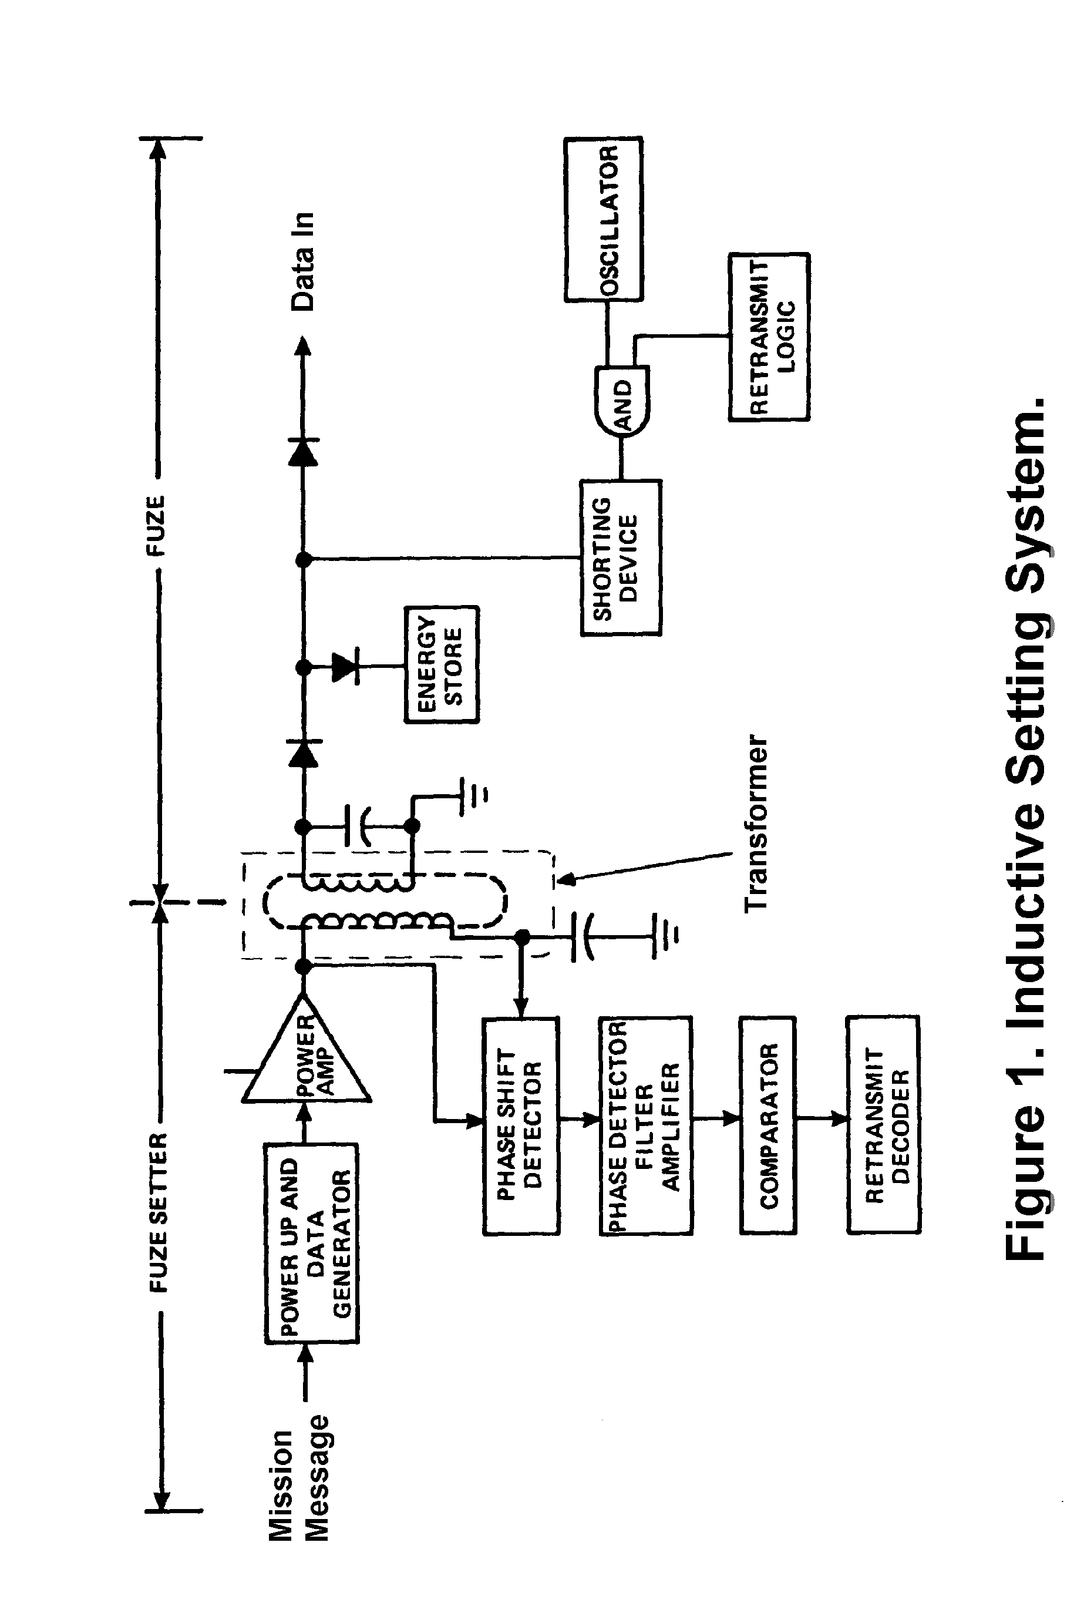

ANNEX A

DEFINITIONS AND ABBREVIATIONS

1. Definitions, terms and acronyms. For the purposes of this AOP, the definitions, terms and acronyms herein shall apply.

2. Carrier rise time. The time required for the envelope of the waveform to change from 10 percent to 90 percent of its specified value.

3. Carrier fall time. The time required for the envelope of the waveform to decay from 90 percent to 10 percent of its specified value.

4. Carrier control signal. An input signal to a setter power amplifier which causes the power amplifier to emit a 100 kilo-Hertz signal.

5. Standard fuze receive coil. A coil with specified dimensions and electrical characteristics. It interfaces with the setter coil through an inductive interface.

6. Standard fuze circuit. The circuit which provides a controlled load across the fuze receive coil. It reduces the impedance during talkback to permit talkback to a fuze setter.

7. Standard power amplifier. A circuit which provides the carrier signal to the standard setter coil in a standard setter. It interfaces with a control circuit to modulate the carrier signal.

8. Standard setter coil. A coil with specified dimensions and electrical characteristics. It is linked to the fuze receive coil through an inductive interface.

9. Standard talkback receiver. The circuit which detects phase shifts in the carrier and defines talkback sensitivity in the standard setter.

10. Talkback control signal. An input to the standard fuze circuitry which is held at 0 volts in the absence of talkback waveform attenuation, and is pulsed at the desired fuze subcarrier rate to communicate with a setter.

11. Talkback signal. An output signal from the standard talkback receiver which contains the reverse message bit pattern from a fuze.

12. BCD. Binard Coded Decimal is a method of using four bit binary representation of each decimal digit. These range from 0000 to 1001 for the decimal values of 0 through 9. BCD uses groups of four binary bits to represent decimal numbers. The values of 1010 through 1111 are invalid binary patterns to represent decimal values of 0 through 9 and are typically represented by letters A through F respectively.

13. MSB. Most Significant Bit has the greatest value and usually is the leftmost unit.

14. LSB. Least Significant Bit has the least value and is usually the rightmost unit.

15. NSB. Near Surface Burst is a fuze proximity function that provides initiation of the explosive train closer than 8 meters to the target or ground.

16. TOF. Time of Flight is the period of time that the fuze is between gun launch and fuze initiation of the explosive train (or ground impact, which every occurs first).

17. HOB. Height of Burst is the distance between the ground and the fuze initiation of the explosive train. It is typically represented in meters and has a range (ie: 8 to 12 meters).

ANNEX B

SETTER DEVELOPMENT TEST PROCEDURE

1. This Annex provides development test procedures for inductive setters.

2. In order to effect interoperability, each setter must be tested with the standard fuze. Other fuzes may be used in addition to the fuze standard at the discretion of the setter developer. The setter will be tested with simulations of all fuzes it intends to set.

3. The developmental inductive fuze setter must be tested to verify that the following parameters are within the guidelines specified in STANAG 4369 and table B-1. The setter must be tested for its ability to receive the fuze talkback in accordance with the registered fuze specific parameters (see Annex E). All the above tests shall be conducted at +25 degrees Celsius. Then the above tests shall be repeated at -46 degrees Celsius and also for +63 degrees Celsius. The carrier intensity must be measured, by using a fuze standard. The voltage induced into the standard fuze will be measured. The rise and fall times shall not exceed the specified limits in table B-1. The setter shall be tested over its expected working environment, including worst case conditions, and properly transmit and receive the setting data.

4. A piece of test equipment called a Programmable Inductive Fuze Standard (PIFS), IL-1510, is available to expedite setter testing. The Programmable Inductive Fuze Standard has been designed to work as a stand-alone unit, in conjunction with other test equipment through an IEEE-488 bus, or with a IBM PC compatible computer with an RS232 serial interface. A frequency counter, storage oscilloscope, and delay circuit (if required) are to be used in conjunction with the PIFS to test the setter. The appropriate fuze specific parameters from Annex E should be used to program the PIFS and the developmental setter shall be exercised by the PIFS to determine the actual setter-generated inductive set parameters. The voltage induced into the receive coil shall be within the range of 42.2 volts +/- 6 volts peak to peak. The specific equipment connections and procedures in the Fuze Standard Manual shall be followed.

5. A laboratory standard fuze receive coil (figure B-1), standard fuze receive coil bobbin (figure B-2), coil housing (see figure B-3) and standard electronic circuitry (figure B-4) can also be used to test the setter. The waveform parameter measurement is made across the fuze receive coil. The input to the standard electronic circuitry is used to modulate a load across the receive coil. The controlling or non-standard part of the
circuit shall control the standard circuitry to simulate the desired fuze-specific parameters (see Annex E). This configuration produces the equivalent of a laboratory type fuze standard. The fuze standard consists of a fuze body, ogive assembly, receive coil assembly, standardized electronics assembly, and non-standard electronics assembly. It provides talkback and data decoding. The body is a modified M767 fuze body, whose contour conforms to STANAG 2916. The ogive is constructed of a non-ferrous material. Wires are connected between the fuze receive coil and the electronics assembly, and then the fuze receive coil assembly is mounted inside the ogive assembly. The ogive assembly is attached to the modified fuze body, and then the entire fuze body and ogive assemblies are attached to a base unit. This laboratory fuze standard can be controlled by a logic breadboard or a computer with the appropriate interface. The non-standardized circuit converts the modulated carrier into the appropriate "1"s and "0"s, stores the data, and then talks back to the setter changing the logic level of the talkback control point as appropriate. This laboratory-type standard fuze can be adjusted to emulate any inductively settable fuze that meets the requirements of STANAG 4369 and this document. The laboratory-type standard fuze permits monitoring of the setter waveform, frequency, forward message, and reverse message signals. The developmental setter shall be tested as indicated in the above paragraph. The waveform induced into the fuze standard shall be measured. The received messages shall be compared to the respective transmitted message and any deviation ("0" instead of a "1", or "1 instead of a "0") shall be counted as a failure. The carrier fall time shall be a maximum of 50 microseconds and the carrier rise time shall be a maximum of 50 microseconds. The setter shall demonstrate that it generates and receives inductive information in accordance with table B-1. The setter must also be tested to verify that the bit-by-bit comparison of talkforward and talkback provides the proper setter response.

6. A supplementary approach is to use readily obtainable autosettable fuzes with an inductive pickup. This method will permit testing the setter with actual production fuzes, but is limited in that the setter is not exercised beyond its nominal tolerances. However, this method will provide a basic test of the setter operation. This method can be used for initial testing of the inductive fuze setter, but the previous method must be used to verify interoperability.

7. The PUP, forward data, forward data "1", forward data "0", D1, and (if applicable) D3 shall be varied over the range permitted in STANAG 4369 to determine the range accepted by the developmental fuze. D2 shall be measured and compared to the proper value. The specific equipment connections and procedures in the Test Set Manual shall be followed.

8. The combination of test fixture, test circuit and test equipment must appear to the setter under test to be a fuze. This fuze simulator must exercise the setter under test to at least the tolerance limits of all parameters controlled by the fuze in such a manner as to verify proper setter operation.

9. The fuze shall initiate talkback after the appropriate delay as defined in Annex E. The fuze shall echo back the data word in accordance with the appropriate fuze specific parameters defined in Annex E. Incorrect fuze ID codes shall be transmitted to the setter to verify proper rejection of incorrect ID codes. The setter shall be tested under worst case conditions and spacing of the setter coil from the fuze.

10. The setter shall be rejected if it fails any of the above tests.

__________________________________________________________
| | | |
| PARAMETER | VALUE | UNITS |
|_____________________________|_________________|________|
| | | |
| PUP | 1 min, 1000 max | ms |
| | | |
| FMW | 275 +/- 5 | ms |
| | | |
| | | |
| D2 | see note 2 | ms |
| | | |
| D3 | 50 max | ms |
| | | |
| carrier frequency | 100 +/- 0.01 | kHz |
| | | |
| forward message bit | | |
| rate | 1000 +/- 10 | bits/s |
| | | |
| rise time (mark-to-space)| 50 max | micro- |
| | | seconds|
| fall time (space-to-mark)| 50 max | micro- |
| | | seconds|
| logic 0 mark | 250 +/- 5 | micro- |
| | | seconds|
| logic 0 space | 750 +/- 5 | micro- |
| | | seconds|
| logic 1 mark | 500 +/- 5 | micro- |
| | | seconds|
| logic 1 space | 500 +/- 5 | micro- |
| | | seconds|
|_____________________________|_________________|________|

Table B-1. Setter Generated Inductive Set Parameters

Notes:

1. The FMW and D1 are both fuze and setter generated
parameters.

2. D2 is given by FMW minus (FMP plus D1 plus RMP).
D2 minimum occurs when (FMP plus D1 plus RMP) equals
the FMW. In this case D2 is zero.
D2 maximum occurs when only 1 data bit is transmitted.
D2 maximum is (275 -(6 + 3 + 36)) or 230 milliseconds.

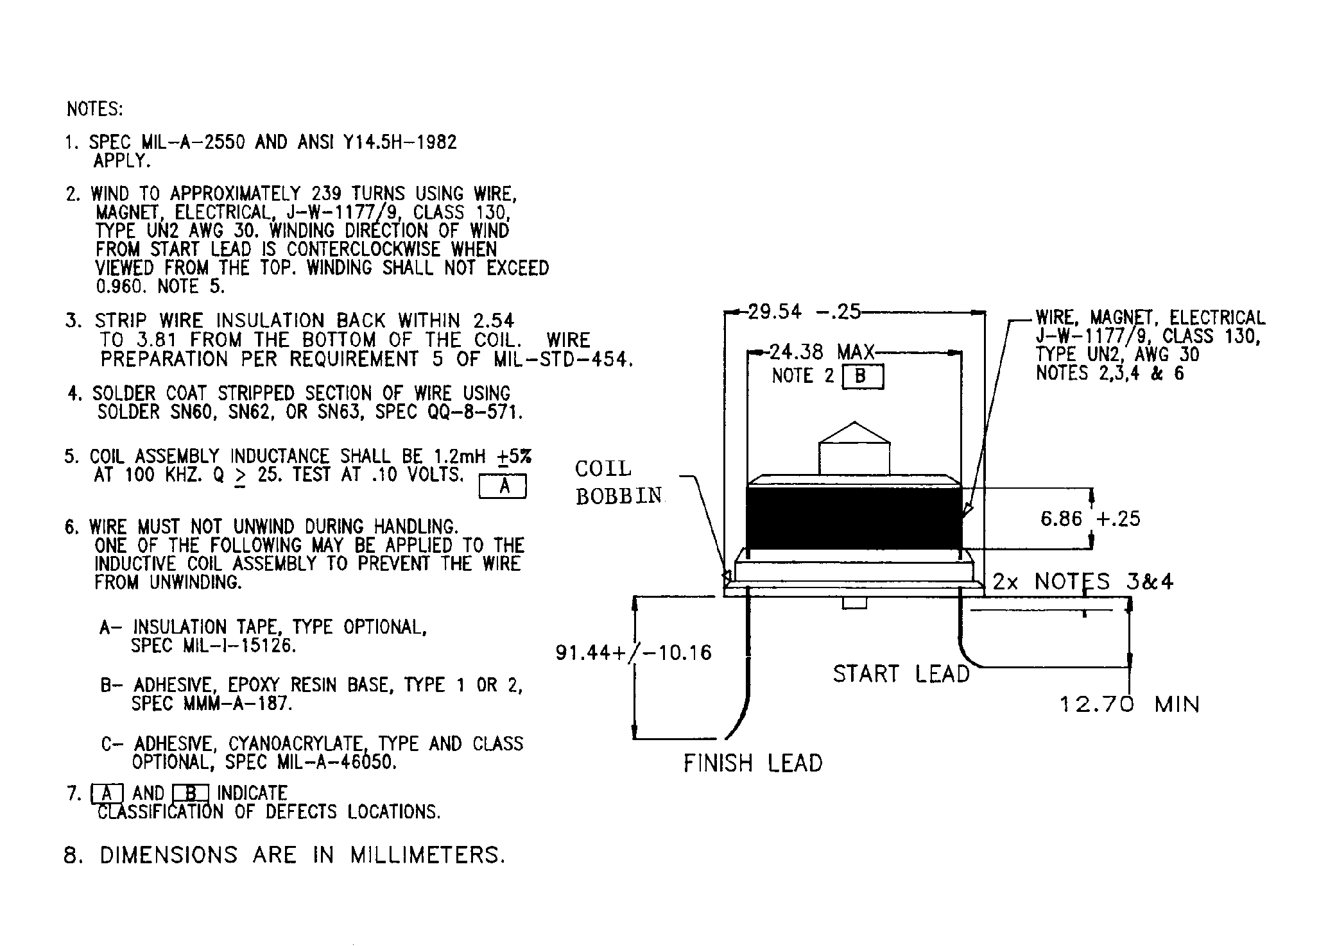

Figure B-1. Standard Fuze Receive Coil

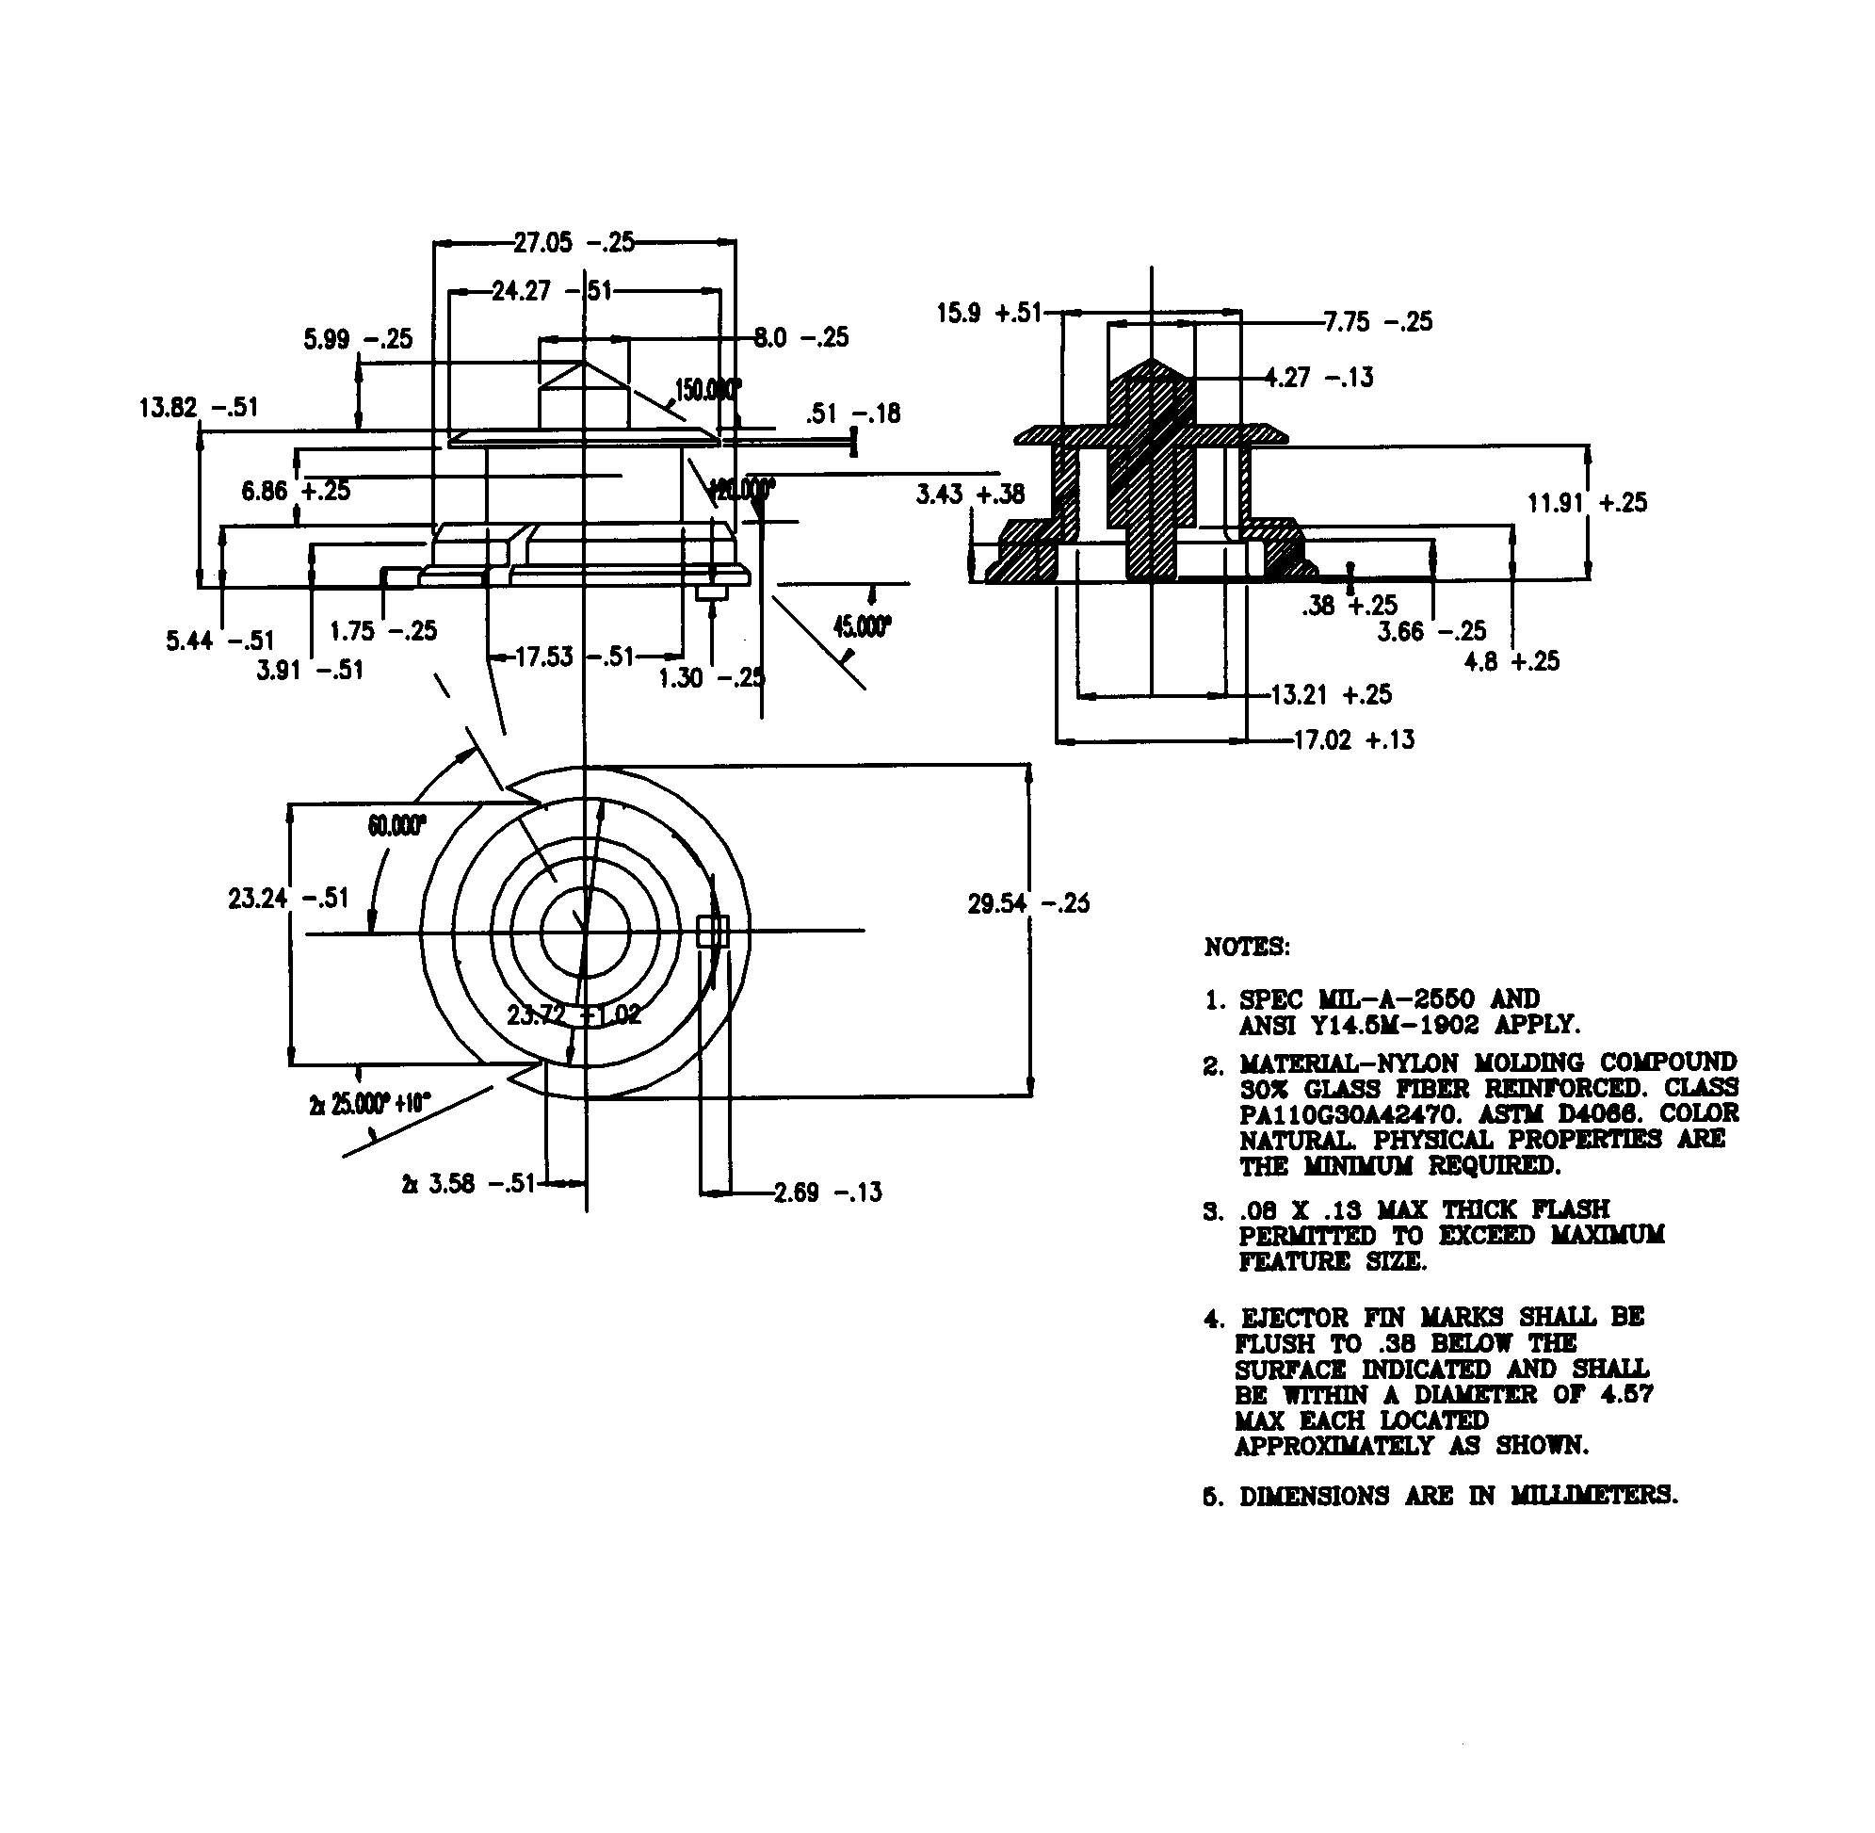

Figure B-2. Standard Fuze Receive Coil Bobbin

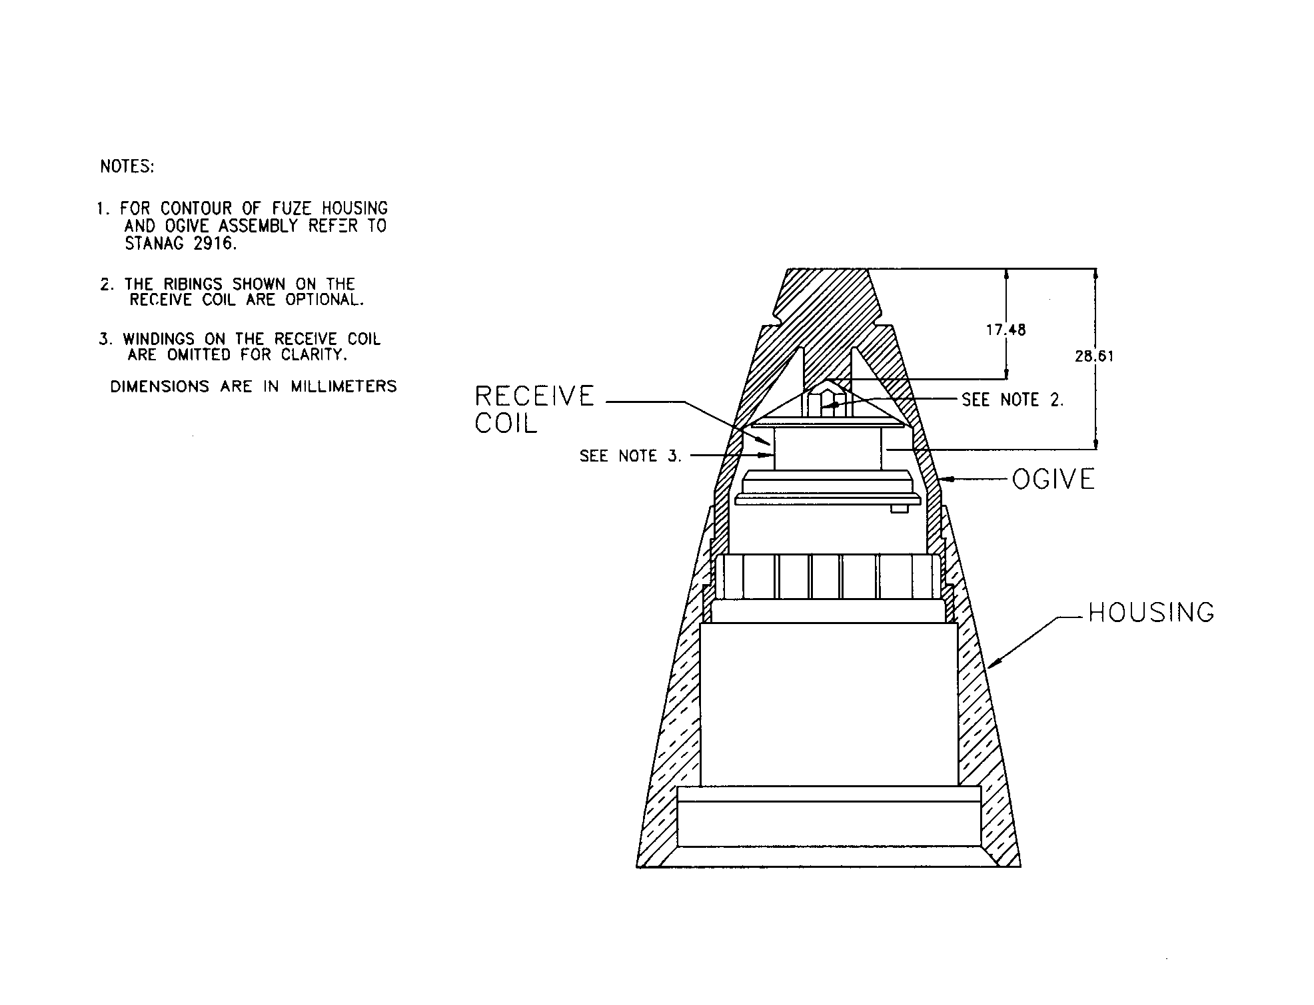

Figure B-3. Standard Fuze Configuration

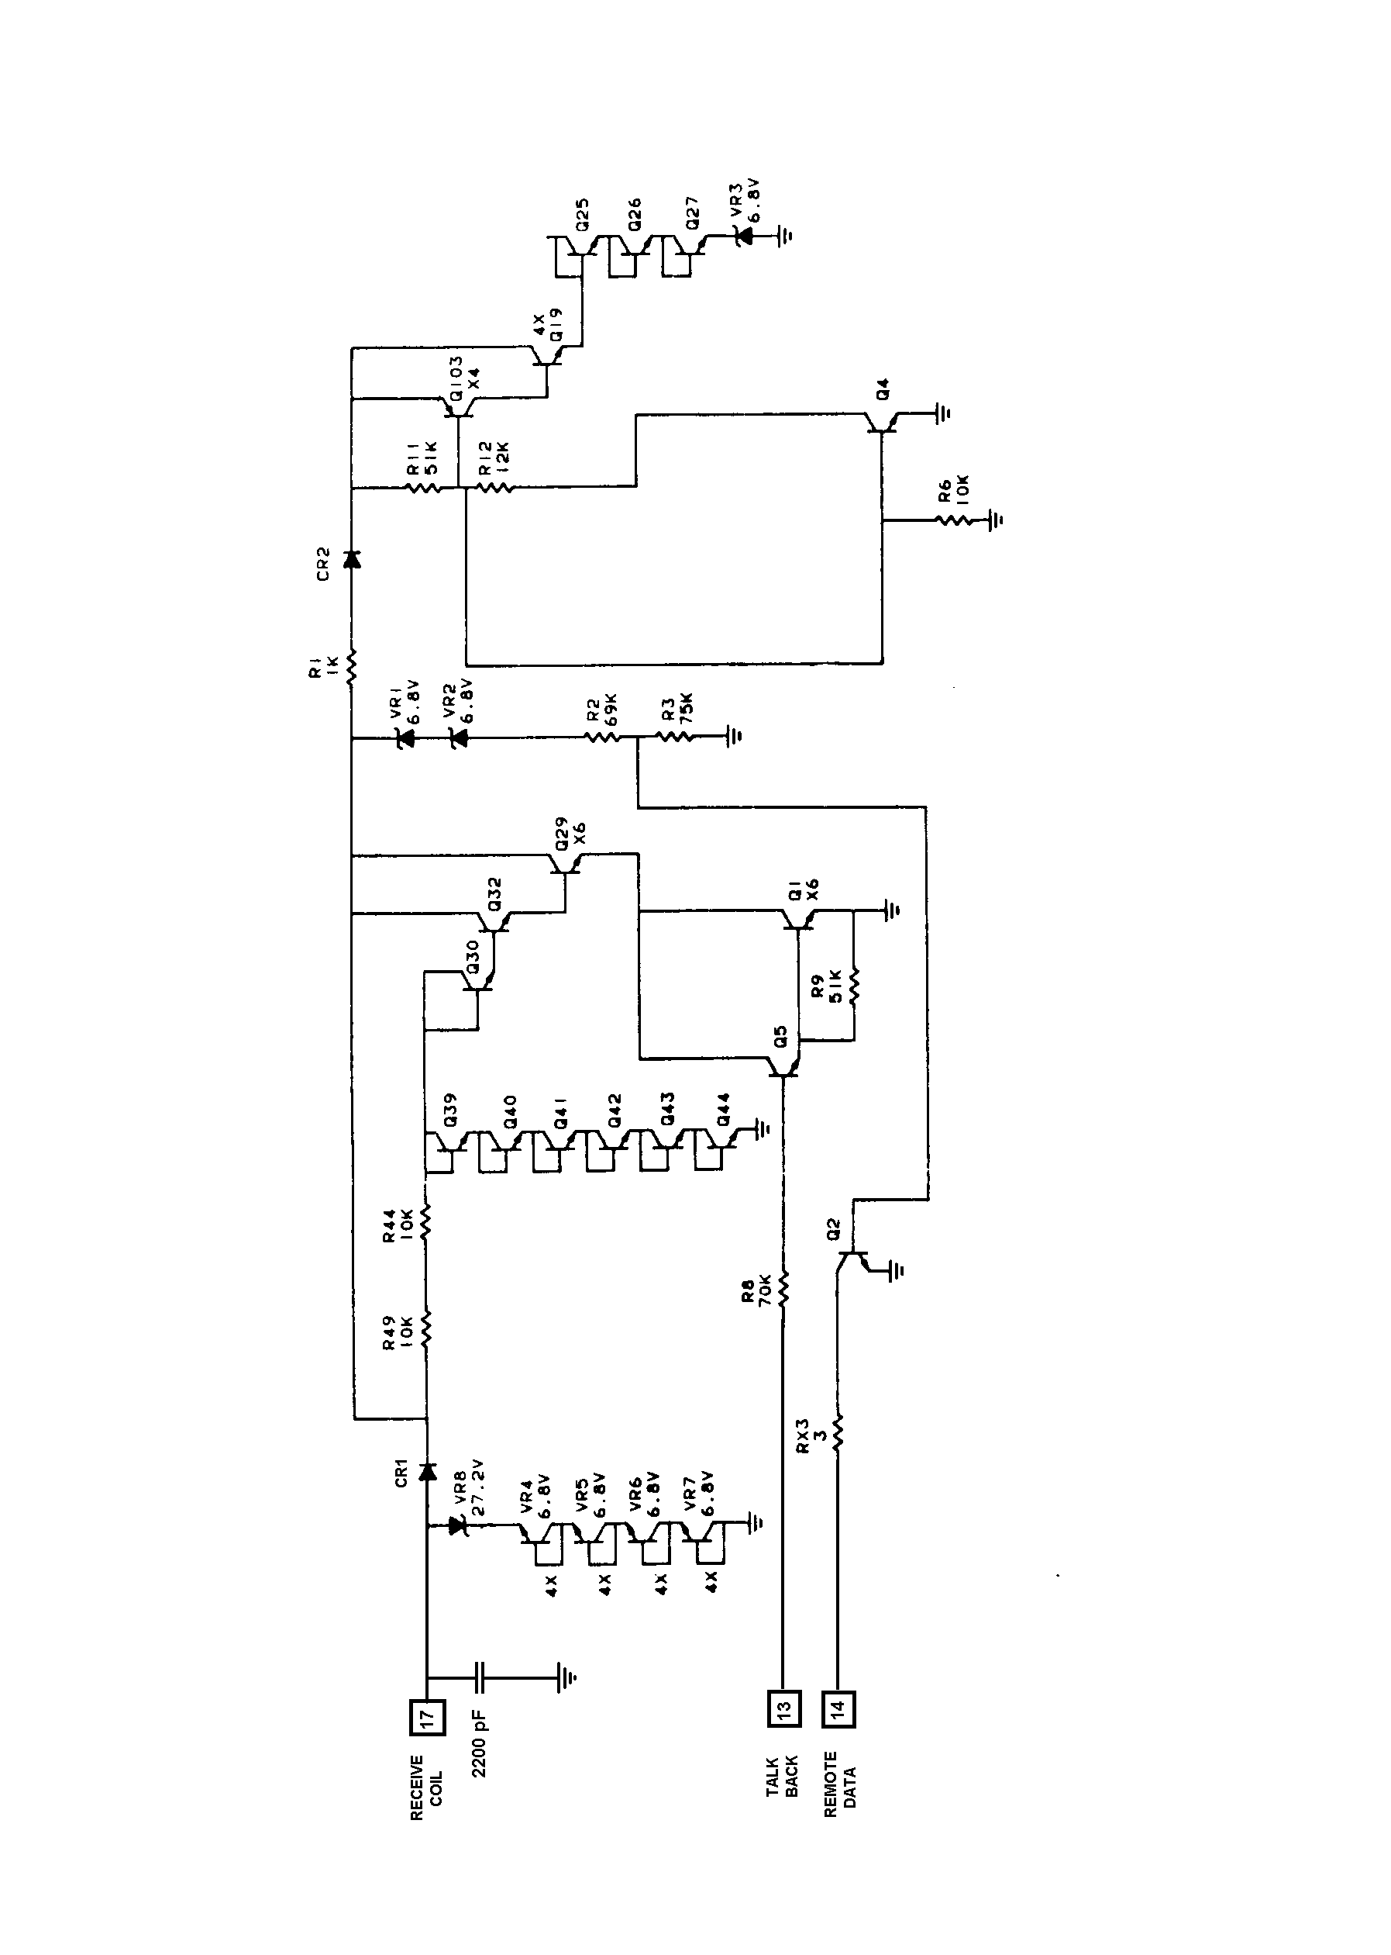

Figure B-4. Standard Fuze Circuitry

ANNEX C

FUZE DEVELOPMENT TEST PROCEDURE

1. This Annex provides procedures for testing inductively set fuzes.

2. Fuze developers require a setter standard. Only the standardized part of the setter standard is shown in any detail. The specified part of the setter standard is called the standardized part. The rest of the standard is called the non-standardized part. The non-standardized part is essentially a controller for the standardized part. The setter standard provides a known digital word format and output signal for use with developmental fuzes. It can vary the PUP, delay between the PUP and the forward message period, and the forward message. Each of the 32 bits of the forward message is individually settable to provide all possible combinations of identification codes and data words. The duty cycle and duration of the "1"s and "0"s is also variable over the range permitted in table C-1. The setter standard output power and frequency are also adjustable over the range permitted in table C-1. Implementation is left to the item developer who may utilize anything from a benchtop collection of laboratory instruments and breadboard circuits to a custom designed automatic tester.

3. Generally, the setter standard exercises the fuze over its range of parameters given by table C-1. It modulates the carrier to provide setting information to the fuze under test in accordance with the appropriate parameters for the fuze in Annex E and STANAG 4369.

4. The Inductive Fuze Setter Test Set, IL-410, is designed to work as a stand-alone unit, in conjunction with other test equipment through an IEEE-488 bus, or with an IBM PC compatible computer with an RS232 serial interface. A frequency counter and storage oscilloscope are to be used in conjunction with this test set to test the fuze. The appropriate fuze specific parameters from Annex E should be used to program the test set, and the developmental fuze shall be exercised to determine the actual fuze-generated inductive set parameters. The test set shall provide a carrier of an amplitude equivalent to inducing a voltage into a standard fuze receive coil from 36.2 volts peak to peak up to 48.2 volts peak to peak. The PUP, forward data, forward data "1", forward data "0", D1, and (if applicable) D3 shall be varied over the range permitted in STANAG 4369 to determine the range accepted by the developmental fuze. D2 shall be measured and compared to the proper value. The specific equipment connections and procedures in the IL-410 Test Set Manual shall be followed.

5. The setter standard is comprised of five parts: Power amplifier board (figure C-1), setter coil (figure C-2), talkback board (figure C-3), interface, and controller board. A computer could be used with the appropriate interface as a controller. A frequency counter and storage oscilloscope are to be used in conjunction with this standard to test the fuze. The appropriate fuze-specific parameters from Annex E should be used to control the power amplifier board, and the developmental fuze shall be exercised to determine the actual fuze generated inductive set parameters. The standard carrier shall be adjusted to the equivalent intensity corresponding to a voltage of 36.2 volts peak to peak and 48.2 volts peak to peak into a standard receive coil.

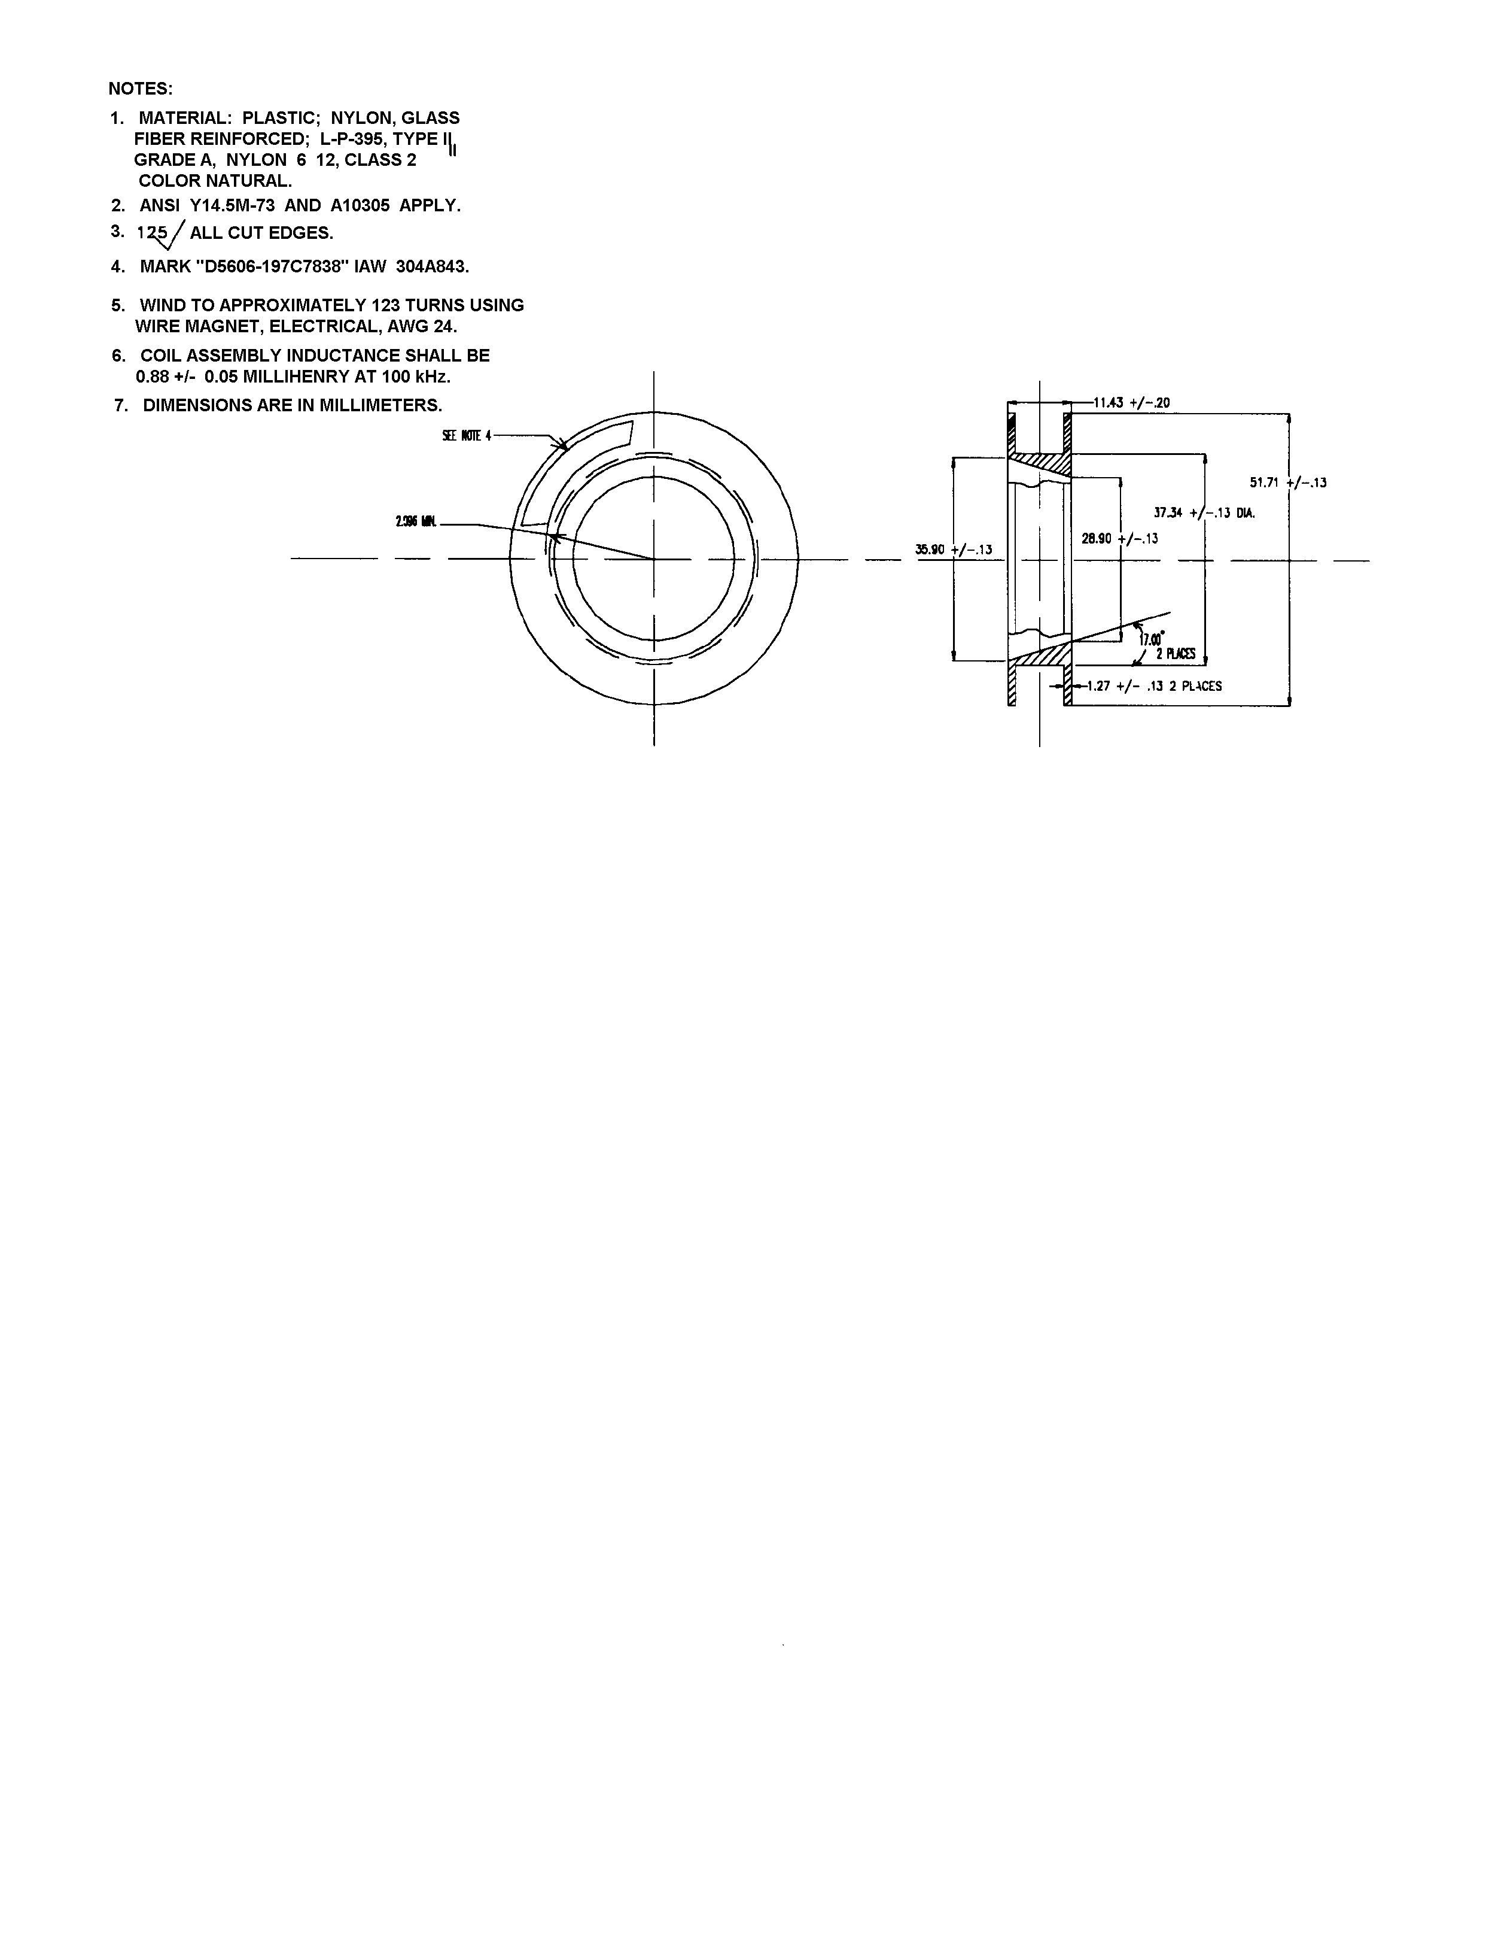

Figure C-1. Standard Setter Coil

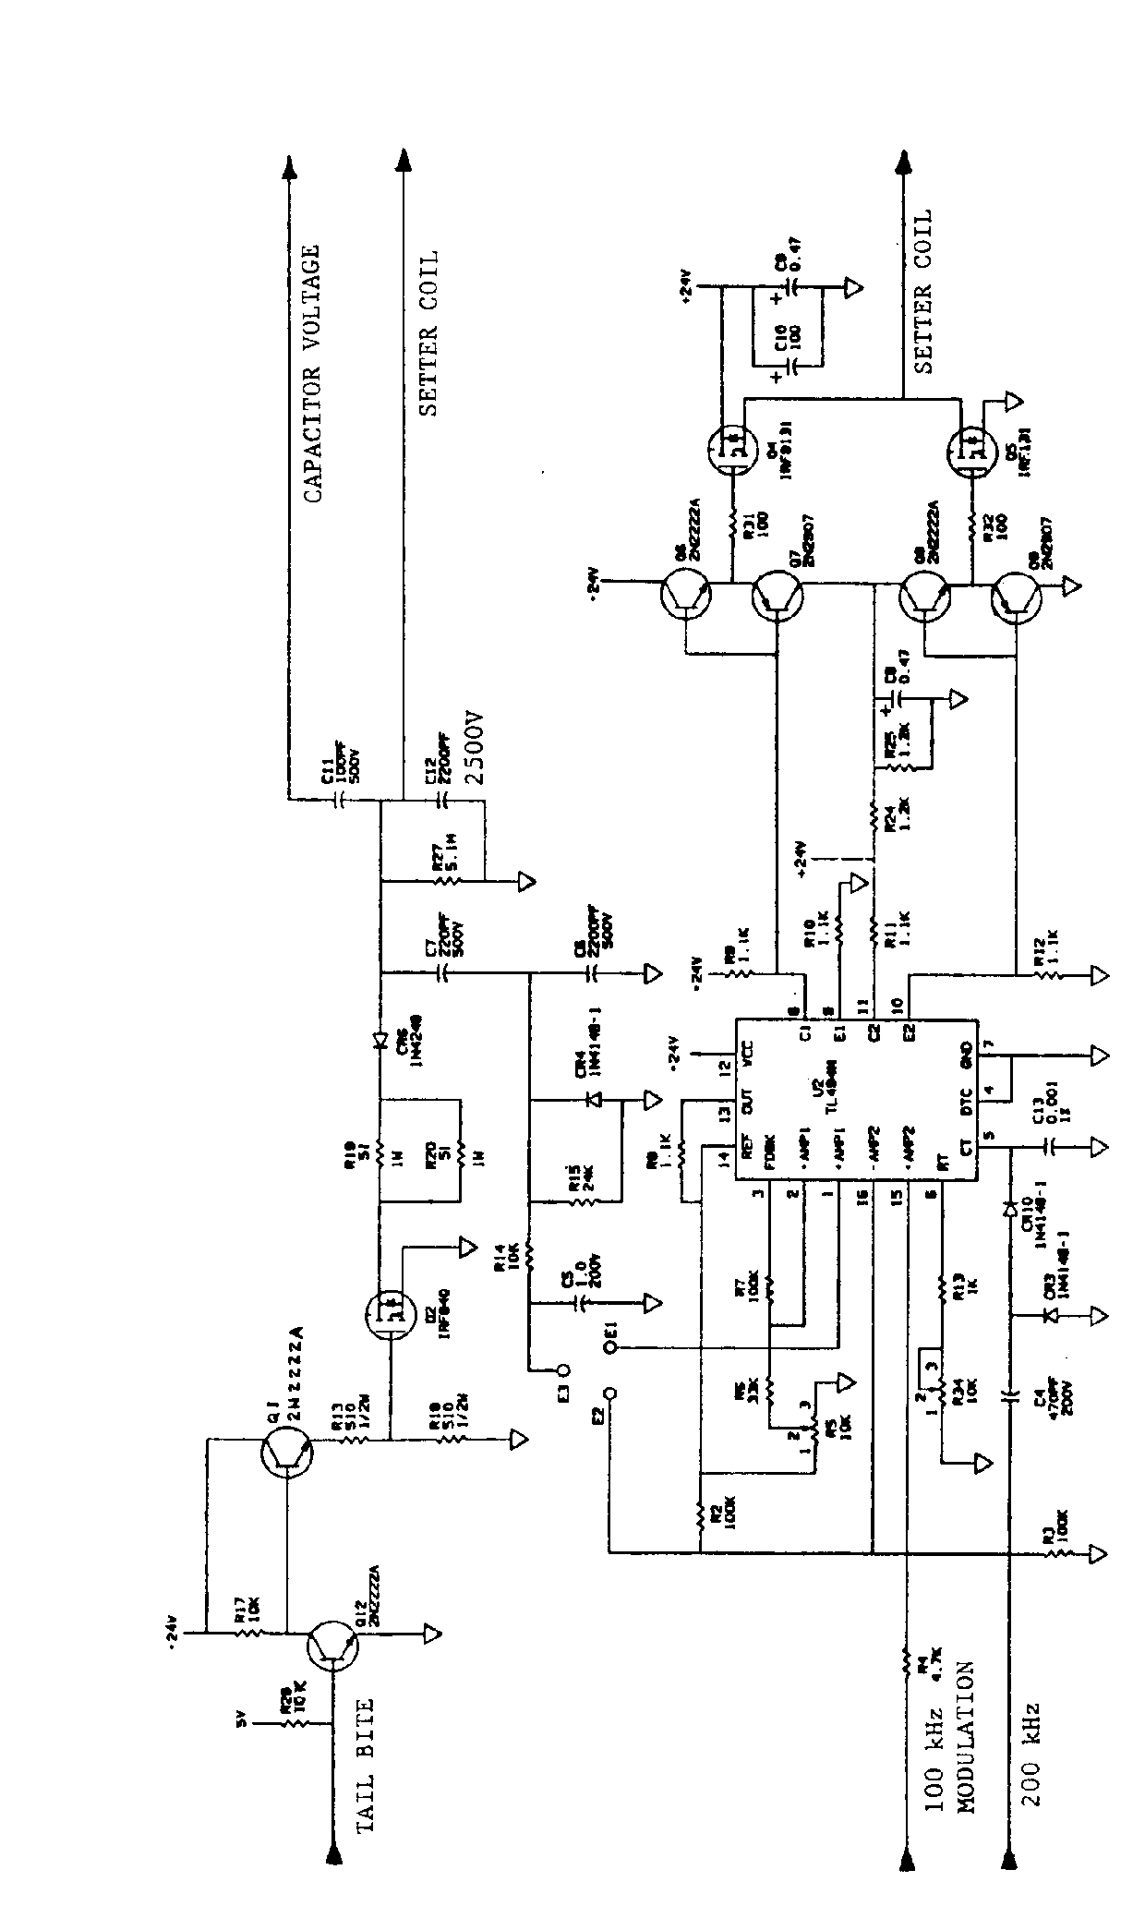

Figure C-2. Standard Power Amplifier
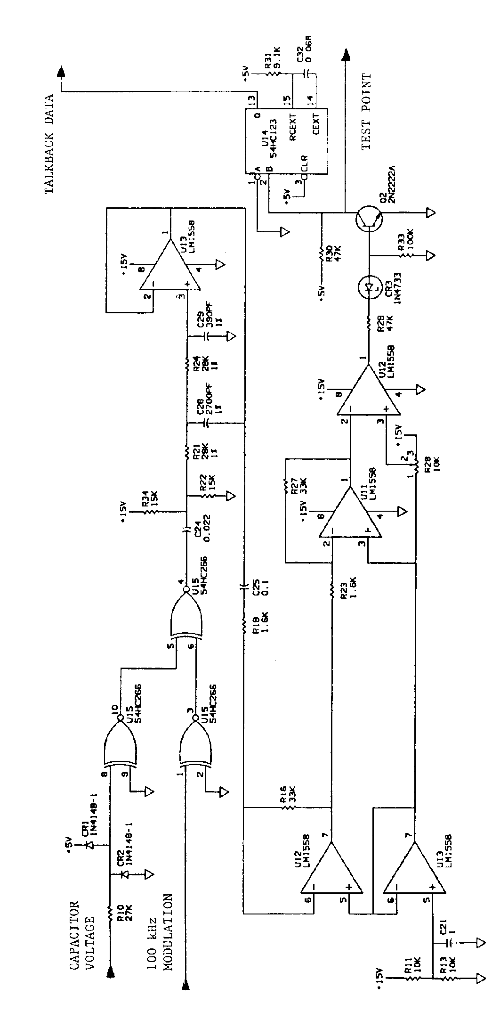

Figure C-3. Standard Talkback Receiver

__________________________________________________________
| | | |
| PARAMETER | VALUE | UNITS |
|_____________________________|_________________|________|
| | | |
| D1 | 3 min, 50 max | ms |
| | | |
| D2 | 0 min, 230 max | ms |
| | | |
| reverse message bit | | |
| | | |
| shorting cycle frequency | 32 x bit rate | Hz |
| | | |
| shorting cycle phase | start with short| |
| | | |
| shorting duty cycle | 50 +/- 5 | percent|
| | | |
| shorting cycle logic 0 | 8 | cycles |
| | | |
| shorting cycle logic 1 | 16 | cycles |
| | | |
| reverse message bit rate | 120 to 165 | bits/s |
| | | |
|_____________________________|_________________|________|

Table C-1. Fuze Generated Parameters

The fuze shall be tested at +25, -46, and 63 degrees Celsius and must meet all of the above parameters, general and specific. The fuze must also provide the correct response to all possible fuze messages at the three temperatures above. The fuze must be tested at the minimum and maximum setter carrier power levels.

ANNEX D

U.S. NAVY SETTER AND FUZE-SPECIFIC PARAMETERS

1. U.S. Navy Setter and Fuzes. An earlier design for an inductively set projectile fuze system resulted in the configuration now deployed by the U.S. Navy. The U.S. Navy's fleet currently has an inductive fuze setter that accommodates a subset of the full range of inductive setting parameters. Fuze developers desiring interoperability with U.S. Navy setters will have to use specific values of several otherwise variable fuze parameters. These parameters and their values are listed in table D-1.

______________________________________________________
| PARAMETER | VALUE | UNITS |
|_____________________________|_________________|________|
| Carrior frequency | 100 +/- .50 | kHz |
| | | |
| PUP | 500 min | ms |
| | | |
| D1 | 4 min | ms |
| | | |
| D2 | 15 max | ms |
| | | |
| D3 | 63 max, Note 3 | ms |
| | | |
| Carrier fall time | 20 max | micro- |
| | | seconds|
| Carrier rise time | 70 max | micro- |
| | | seconds|
| Start bit | yes | |
| | | |
| Data bits | 20, Note 1 | number |
| | | |
| FMP | 26 +/- 0.26 | ms |
| | | |
| reverse message bit rate | 120 to 165 | bits/s |
| | | |
| RMP | 275 +/- 5 | ms |
| | | |
| FMW number | 1, Note 2 | number |
| | | |
| FMW | 275 max | ms |
| | | |
| Subcarrier frequency | 4560 +/- 720 | Hz |
|_____________________________|_________________|________|

Table D-1. Parameters for U.S. Navy Fuze Setter Compatibility.

NOTE:

1. The last of the 20 data bits shall be a logic 0; only
the first 19 data bits may be programmed arbitrarily.
2. Multiple FMWs are not permitted.
3. The Navy setter is capable of continuously transmitting
updated information to the fuze. D3 can be zero.
4. All other corresponding parameters given by STANAG 4369
are unchanged.

2. The maximum power required by the fuze shall be less than that available from a MK 34 Electronic Fuze Setter (EFS) End-of-Life magnetic field (Table D-2), when the nose of the fuze is separated from the MK 34 EFS coil assembly by one inch. The typical power parameters of Table D-2 is given for reference and represents the magnetic field intensity a fuze may be exposed to within a MK 45 MOD 1 gun mount.

Minimum End-Of-Life
Power Curve

Distance Power
(inches) (milliwatts)

0.5 114
1.0 115
1.5 103
2.0 85
2.5 69
3.0 55
3.5 44
4.0 36
4.5 29
5.0 24

Table D-2. U.S. Navy Setter Energy Profile.

ANNEX E

REGISTERED FUZE IDENTIFICATION CODES

Annex E is comprised of the following: Table E-1, which lists registered fuzes and their associated fuze ID codes; table E-2, which is the fuze registration form; table E-3, which contains National Points of Contact; and tables E-4 through E-39, which contain fuze bit allocations and fuze specific data.

ID FUZE DATA REGISTERING
CODE MESSAGE NATION
LENGTH (bits)
________________________________________________________________

00000 N/A - Command mode Not Applicable
00001 M762 14 USA - ARMY
00010 XM773 18 USA - ARMY
00011 M767 14 USA - ARMY
00100 MK 419 20 USA - NAVY
00101 DM-52 14 DEU - ARMY
00110 MK-437 20 USA - NAVY
00111 C32 15 CAN
01000 M782 18 USA - ARMY
01001 DM-74 15 DEU - ARMY
01010 FUCHSIA 15 FRA - ARMY
01011 FRAPPE 15 FRA - ARMY
01100 DM-84 16 DEU - ARMY
01101 MK 432 20 USA - NAVY
10000001 XM7 51 FRA – ARMY
10000010 XM8 51 FRA – ARMY
10000011 L163 14 GBR – ARMY
10000100 L166 14 GBR – ARMY

1XXXX Split ID code/Multiple FMW Not Applicable

Table E-1. Registered Fuze Identification Codes

Fuze Registration Form

Fuze nomenclature, description, bit allocation, bit significance, and functional modes:

In order to update the Fuze Setters to insure interchangeability between NATO PN, describe here the differents functional modes (eg. calibration of the fuze, fuze built-in test circuitry...)

Each fuze specific parameters are defined in table E-2 below.”

PARAMETER VALUE UNITS_________

Power up period milliseconds (minimum)

D1 milliseconds (nominal+/-)

D2 milliseconds (nominal)

D3 milliseconds (minimum)

Start bit yes or no

Data bits per FMW

First FMW number
Additional FMWs (specify on additional pages as required)

Reverse message bit rate bits/sec (nominal)

Forward message windows number

Subcarrier frequency Hz (nominal)

Table E-2. Fuze Registration Form

NATION ORGANIZATION NAME ADDRESS

Germany BWB BWB K 1.3
Ferdinand-Sauerbruch-Str.1
56073 Koblenz am Rhein
Germany

Italy MINISTERO DELLA DIFESA Via Marsala, 104
DIREZIONE GENERALE DEGLI ARMAMENTI TERRESTI 00100, Roma
I Reparto – 2ª Divisione Italy

USA US ARMY FUZE Chris Janow US ARMY ARDEC
MANAGEMENT OFFICE ATTN: AMSRD-AAR-AIF
Picatinny Arsenal, NJ
07806-5000
USA

France DGA DGA/INSP/IPE
Cité de l'air - Bâtiment Rotonde
5 bis, avenue de la Porte de Sèvres
75509 Paris Cedex 15

Table E-3. National Points of Contact

Fuze, Electronic Time, M762 Description. The M762 has two functional modes which are programmed with 14 data bits, as summarized in table E-4. The sixth bit controls the functional mode (0=time, 1=impact). In the time mode, the fuze can be programmed from 0.5 seconds to 199.9 seconds in 0.1 second increments. The seventh bit controls the most significant time character (1 = add 100 seconds). The next 12 bits are grouped into three binary coded decimals that represent tens, units and tenths of a second, respectively. The latest version, M762A1, incorporates two new features, interrogation command and battery status query. An ID bit pattern of all "0"s programs the fuze to accept the subsequent data bits as a command such as interrogate (twenty data bit "1"s) or battery status query (0000011111111111111111110). Otherwise the fuze is in the set mode. Upon receipt of the command mode interrogate function (0000011111111111111111111), the fuze will generate a reverse data message bit pattern, starting with its ID code and continuing with a representation of the data in its memory. After receiving the battery status query the fuze will talk back the message "0000000000000000000000001" to indicate that the battery was never activated or it would talk back "0000000000000000000000010" to indicate that the battery was activated. If the battery was activated and is dead at the time of interrogation the fuze sends no talkback data. The fuze does not alter its mission memory upon receipt of the interrogate command or a battery status query.

M762 fuze specific parameters are defined in table E-5.

IDENTIFICATION CODE BIT SEQUENCE 1 2 3 4 5

0 0 0 0 1

DATA BIT SEQUENCE 6 7 8 9 10 11 12 13 14 15 16 17 18 19

IMPACT MODE 1 0 1 0 0 1 1 0 0 0 0 0 0 0

M
TIME MODE 0| S| tens | ones | tenths |
B
0|100| 80 40 20 10 | 8 4 2 1 |.8 .4 .2 .1|

BCD = binary coded decimal
MSB = most significant bit
LSB = least significant bit

Table E-4. M762 Fuze Bit Allocation

__________________________________________________________
| | | |
| PARAMETER | VALUE | UNITS |
| | | |
|_____________________________|_________________|________|
| | | |
| PUP | 500 minimum * | ms |
| D1 | 12.5 +/- 1.25 | ms |
| D2 | 124.75 | ms |
| ID bits | 00001 | |
| Start bit | no | |
| Data bits | 14 | number |
| FMP | 19 +/- 0.2 | ms |
| Reverse message bit rate | 160 +/- 4.0 | bits/s |
| RMP | 118.75 +/- 3.0 | ms |
| FMW number | 1 | number |
| Subcarrier frequency | 5120 +/- 128 | Hz |
| | | |
|_____________________________|_________________|________|

* After battery activation the power up period can be from nine to one thousand milliseconds in duration.

Table E-5. M762 Fuze Specific Parameters.

Fuze, Electronic Time, M767 Description. The functional modes and message data of the M767 are identical to those of the M762. The M767 has two functional modes which are programmed with 14 data bits, as summarized in table E-6. The sixth bit controls the functional mode (0=time, 1=impact). In the time mode, the fuze can be programmed from 0.5 seconds to 199.9 seconds. in 0.1 second. increments. The seventh bit controls the most significant time character (1 = add 100 seconds). The next 12 bits are grouped into three binary coded decimals that represent tens, units and tenths of a second, respectively. The latest version, M767A1, incorporates two new features, interrogation command and battery status query. An ID bit pattern of all "0"s programs the fuze to accept the subsequent data bits as a command such as interrogate (twenty data bit "1"s) or battery status query (0000011111111111111111110). Otherwise the fuze is in the set mode. Upon receipt of the command mode interrogate function (0000011111111111111111111), the fuze will generate a reverse data message bit pattern, starting with its ID code and continuing with a representation of the data in its memory. After receiving the battery status query the fuze will talk back the message "0000000000000000000000001" to indicate that the battery was never activated or it would talk back "0000000000000000000000010" to indicate that the battery was activated. If the battery was activated and is dead at the time of interrogation the fuze sends no talkback data. The fuze does not alter its mission memory upon receipt of the interrogate command or a battery status query.

M767 fuze specific parameters are listed in table E-7.

IDENTIFICATION CODE BIT SEQUENCE 1 2 3 4 5

0 0 0 1 1

DATA BIT SEQUENCE 6 7 8 9 10 11 12 13 14 15 16 17 18 19

IMPACT MODE 1 0 1 0 0 1 1 0 0 0 0 0 0 0

M
TIME MODE 0| S| tens | ones | tenths |
B
0|100| 80 40 20 10 | 8 4 2 1 |.8 .4 .2 .1|

BCD = binary coded decimal
MSB = most significant bit
LSB = least significant bit

Table E-6. M767 Bit Allocation

__________________________________________________________
| | | |
| PARAMETER | VALUE | UNITS |
| | | |
|_____________________________|_________________|________|
| | | |
| PUP | 500 minimum * | ms |
| D1 | 12.5 +/- 1.25 | ms |
| D2 | 124.75 | ms |
| ID bits | 00011 | |
| Start bit | no | |
| Data bits | 14 | number |
| FMP | 19 +/- 0.2 | ms |
| Reverse message bit rate | 160 +/- 4.0 | bits/s |
| RMP | 118.75 +/- 3.0 | ms |
| FMW number | 1 | number |
| Subcarrier frequency | 5120 +/- 128 | Hz |
| | | |
|_____________________________|_________________|________|

* After battery activation the power up period can be from nine to one thousand milliseconds in duration.

Table E-7. M767 Fuze Specific Parameters.

Fuze, Multi-Option, XM773 Description. The XM773 has four functional modes which are programmed with 18 data bits, as summarized in table E-8. The sixth bit determines whether the self-TM mode is on ("1") or off ("0"). The seventh bit controls the most significant time character (1 = add 100 seconds). The next 12 bits are grouped into three binary coded decimals that represent tens, units and tenths of a second, respectively in a binary coded decimal format. The fuze modes (time, proximity, near surface burst, impact and delay modes are selected by bits 7, 8, 9, and 10. This bit allocation system has room for additional functional modes. The proximity turn-on time is programmed in integer second increments. The fuze will accept input of decimal proximity turn-on times but will truncate the tenths value to zero and talkback the integer portion followed by zero tenths.

XM773 fuze specific parameters are listed in table E-9.

IDENTIFICATION CODE BIT SEQUENCE 1 2 3 4 5

0 0 0 1 0

BIT 6

0
M
| S | tens | ones | tenths |
MODE B
| SELECTION |100| 80 40 20 10| 8 4 2 1| .8 .4 .2 .1|

DATA BIT SEQUENCE 7 8 9 10 11 12 13 14 15 16 17 18 19 20 21 22 23

TIME MODE 0 0 0 1 X X X X X X X X X X X X X

IMPACT MODE 1 0 0 0 1 1 1 1 1 1 1 1 1 1 1 1 1

DELAY MODE 1 0 1 0 1 1 1 1 1 1 1 1 1 1 1 1 1

PROXIMITY 0 0 1 0| TOF uses the time mode format | 0 0 0 0 |

BCD = Binary Coded Decimal
MSB = Most Significant Bit
LSB = Least Significant Bit
NSB = Near Surface Burst
TOF = Time of Flight
X can be a "0" or a "1"

Table E-8. XM773 Bit Allocation

__________________________________________________________
| | | |
| PARAMETER | VALUE | UNITS |
| | | |
|_____________________________|_________________|________|
| | | |
| PUP | 500 minimum | ms |
| D1 | 12.5 +/- 1.25 | ms |
| D2 | 95.75 +/- 4.95 | ms |
| ID bits | 00010 | |
| Start bit | no | |
| Data bits | 18 | number |
| FMP | 23 +/- 0.2 | ms |
| Reverse message bit rate | 160 +/- 4.0 | bits/s |
| RMP | 143.75 +/- 3.5 | ms |
| FMW number | 1 | number |
| Subcarrier frequency | 5120 +/- 128 | Hz |
| | | |
|_____________________________|_________________|________|

Table E-9. XM773 Fuze Specific Parameters.

Fuze, Electronic Time, ZTZ DM-52 description. The DM-52 has one functional mode, which is programmed with 14 data bits, as summarized in table E-10. The sixth bit must be a "0". The fuze can be programmed for function times of from 2.0 seconds to 199.9 seconds in 0.1 second increments. The seventh bit controls the most significant time character (1 = 100 seconds). The next 12 bits are grouped into three binary coded decimals that represent tens, units and tenths of a second, respectively.
The latest version, ZTZ DM-52A2, incorporates the following command modes: RESET MODE and INTERROGATION MODE.

ZTZ DM-52 fuze specific parameters are defined in table E-11.

IDENTIFICATION CODE BIT SEQUENCE 1 2 3 4 5

0 0 1 0 1

DATA BIT SEQUENCE 6 7 8 9 10 11 12 13 14 15 16 17 18 19

TIME MODE 0 MSB | LSB |

BCD = binary coded decimal
MSB = most significant bit
LSB = least significant bit

Table E-10. ZTZ DM-52 Fuze Bit Allocation

__________________________________________________________
| | | |
| PARAMETER | VALUE | UNITS |
| | | |
|_____________________________|_________________|________|
| | | |
| PUP | 500 +/- 5 | ms |
| D1 | 12.5 +/- 1.5 | ms |
| D2 | 125 +/- 10 | ms |
| ID bits | 00101 | |
| Start bit | no | |
| Data bits | 14 | number |
| FMP | 19 +/- 0.2 | ms |
| Reverse message bit rate | 160 +/- 4 | bits/s |
| RMP | 118.75 +/- 3 | ms |
| FMW number | 1 | number |
| Subcarrier frequency | 5115 +/- 128 | Hz |
| | | |
|_____________________________|_________________|________|

Table E-11. ZTZ DM-52 Fuze Specific Parameters.
Fuze, Multi-Function, MK 419 Description. The MK 419 is designed to be compatible with the US Navy setter parameters. It functions in the point detonate, electronic time, surface proximity, and air proximity modes, as summarized in Table E-12. The electronic time mode is settable to 163.83 seconds in 0.01 second increments. The surface proximity mode (HOB) can be set to a height of burst from +65 to -90 feet, in 5 foot increments, and for a time of flight to 255 seconds, in 1 second increments. In the AIR mode, it can be set for closing velocities of an incoming target from 822 ft/s to 6156 ft/s and with a time of flight up to 31 seconds, in 1 second increments. It can also be set to an autonomous mode, in which it will function in the AIR mode for 10 seconds, then begin searching for surface targets as in HOB mode. In all modes, there is a self-telemetry option that can be enabled by setting bit 24 to 1. Bit 25 is a parity bit to maintain even parity throughout the entire 26 bit message. All times are sent in binary format, with the least significant digit representing 10 milliseconds in the ET mode and 1 second in all other modes.

MK 419 fuze specific parameters are listed in table E-13.

START BIT 1

1

IDENTIFICATION CODE BIT SEQUENCE 2 3 4 5 6

0 0 1 0 0

MODE SELECT BITS 7 8 9

AUTONOMOUS (AUTO) 0 0 0
POINT DETONATION (PD) 0 0 1
ELECTRONIC TIME (ET) 0 1 0
SURFACE TARGET PROXIMITY (HOB) 0 1 1
AIR TARGET PROXIMITY (AIR) 1 0 0

AUTO MODE:
| Transition Time |
BIT SEQUENCE | 10 11 |

BIT VALUE
10 seconds | 0 0 |
2 seconds | 0 1 |
4 seconds | 1 0 |
5 seconds | 1 1 |

In AUTO Mode, the transition time from air target to surface target can be modified as shown above when telemetry is enabled (bit 24). If telemetry is not enabled, BITS 10 and 11 should be set to 0. BITS 12-23 are always 0 in AUTO Mode.

Table E-12. MK 419 Fuze Bit Allocation

PD MODE:
| Time of flight (sec) |
BIT SEQUENCE | 10 11 12 13 14 15 16 17 | 18 19 20 21 22 23

BIT VALUE | 128 64 32 16 8 4 2 1 | 0 0 0 0 0 0

PD Mode accepts TOF up to 255 sec in increments of 1 second. BITS 18-23 are always 0 in PD Mode.

ET MODE:

BIT SEQUENCE 10 11 12 13 14 15 16 17 18 19 20 21 22 23

BIT VALUE 81.92 40.96 20.48 10.24 5.12 2.56 1.28 .64 .32 .16 .08 .04 .02 .01 (sec)

HOB MODE :
| HOB (ft) || Time of flight to target (sec) |
BIT SEQUENCE | 10 11 12 13 14 || 15 16 17 18 19 20 21 22 | 23

BIT VALUE | 80 40 20 10 5 || 128 64 32 16 8 4 2 1 | 0

Height of burst is determined by subtracting HOB value (binary value x 5) from 65 feet. BIT 23 is always zero in HOB Mode.

AIR MODE:
| Time of flight (sec)|| relative closing velocity (ft/s) |
BIT SEQUENCE | 10 11 12 13 14 || 15 16 17 18 19 20 21 |

BIT VALUE | 16 8 4 2 1 || 2688 1344 672 336 168 84 42 |

BIT 22 23
Self-Destruct Enable Clutter-Rejection Enable

Closing Velocity is determined by adding CV value (binary value x 42) to 822 ft/s. Self-Destruct and Clutter-Rejection are each enabled when their respective bits are set to 1 (disabled when set to 0).

BIT 24 25 26
SELF-TM PARITY 0

HOB = Height of Burst

Table E-12. MK 419 Fuze Bit Allocation (continued).

________________________________________________________
| | | |
| PARAMETER | VALUE | UNITS |
| | | |
|_____________________________|_________________|________|
| | | |
| PUP | 500 minimum | ms |
| D1 | 4 minimum | ms |
| D2 | 0 to 15 | ms |
| D2 | 0 to 63 | ms |
| ID bits | 00100 | |
| Start bit | yes | |
| Stop bit | yes | |
| Data bits | 20 | number |
| FMP | 26 | ms |
| Reverse message bit rate | 142.5 +/- 22.5 | bits/s |
| RMP | 210.5 +/- 28.7 | ms |
| FMW number | 1 | number |
| Subcarrier frequency | 4560 +/- 720 | Hz |
| | | |
|_____________________________|_________________|________|

Table E-13. MK 419 Fuze Specific Parameters.

Fuze, Electronic Time, MK 432 Description. The MK 432 is an electronic time fuze that is programmed with 20 data bits including a parity bit, as summarized in table E-14. The fuze can be programmed from 0.5 seconds to 327.66 seconds in 0.01-second increments.

MK 432 fuze specific parameters are defined in table E-15.

START BIT 1
1

IDENTIFICATION CODE BIT SEQUENCE 2 3 4 5 6

0 1 1 0 1

MODE SELECT 7 8 9
0 1 0

NOTE: The MK 432 only has a time mode, bits 7, 8 and 9 are always set to 0, 1 and 0 respectively.

DATA BIT SEQUENCE 10 11 12 13 14 15 16 17
BIT VALUE 163.84 81.92 40.96 20.48 10.24 5.12 2.56 1.28

DATA BIT SEQUENCE 18 19 20 21 22 23 24 25
BIT VALUE 0.64 0.32 0.16 0.08 0.04 0.02 0.01 Parity Bit

STOP BIT 26
0

Table E-14. MK 432 Fuze Bit Allocation

__________________________________________________________
| | | |
| PARAMETER | VALUE | UNITS |
| | | |
|_____________________________|________________|________ |
| | | |
| PUP | 500 minimum | ms |
| D1 | 4 minimum | ms |
| D2 | 0 to 15 | ms |
| D3 | 0 to 63 | ms |
| ID bits | 01101 | |
| Start bit | yes | |
| Stop bit | yes | |
| Data bits | 20 | number |
| FMP | 26 | ms |
| Reverse message bit rate | 142.5 +/- 22.5 | bits/s |
| RMP | 210.5 +/- 28.7 | ms |
| FMW number | 1 | |
| Subcarrier frequency | 4560 +/- 720 | Hz |
|_____________________________|________________|________ |

Table E-15. MK 432 Fuze Specific Parameters.

Fuze, Multi-role, C32 description. The C32 has four functional modes, which are summarized in table E-16. The sixth bit controls the impact mode (1 = impact). The seventh bit controls the most significant time character (1 = add 100 seconds). The next 12 bits are grouped tens, ones, and tenths of a second respectively in binary coded decimal format. Bit 20 selects the proximity mode when data bit six is a "0". The fuze can be programmed from 1.0 seconds to 199.9 seconds in 0.1 second increments for time and impact function and from 7 seconds to 199.9 seconds for the proximity function.

C32 multi-role fuze specific parameters are defined in table E-17.

IDENTIFICATON CODE BIT SEQUENCE 1 2 3 4 5

0 0 1 1 1

DATA BIT SEQUENCE 6 7 8 9 10 11 12 13 14 15 16 17 18 19 20

IMPACT DELAY 1 0 0 0 0 0 0 0 0 0 0 0 0 0 0

IMPACT SQ 1 TIME OF FLIGHT IN THE SAME FORMAT AS TIME MODE 0

M
TIME MODE 0| S | tens | ones | tenths | 0
B
|100| 80 40 20 10 | 8 4 2 1 |.8 .4 .2 .1 |

PROXIMITY 0 TIME OF FLIGHT IN THE SAME FORMAT AS TIME MODE 1

BCD = binary coded decimal
MSB = most significant bit
LSB = least significant bit

Table E-16. C32 Multi-role Fuze Bit Allocation

__________________________________________________________
| | | |
| PARAMETER | VALUE | UNITS |
| | | |
|_____________________________|_________________|________|
| | | |
| PUP | 500 +/- 5 | ms |
| D1 | 34.5 +/- 1 | ms |
| D2 | 95 +/- 10 | ms |
| ID bits | 00111 | |
| Start bit | no | |
| Data bits | 15 | number |
| FMP | 20 +/- 0.2 | ms |
| Reverse message bit rate | 160 +/- 4 | bits/s |
| RMP | 125 +/- 3.25 | ms |
| FMW number | 1 | number |
| Subcarrier frequency | 5115 +/- 128 | Hz |
| | | |
|_____________________________|_________________|________|

Table E-17. C32 Multi-role Fuze Specific Parameters.

Fuze, Multi-Option, M782 Description. The M782 is an autoset only fuze which has four functional modes which are programmed with 18 data bits, as summarized in table E-18. The sixth bit determines whether the self-TM mode is on ("1") or off ("0"). The seventh bit controls the most significant time character (1 = add 100 seconds). The next 12 bits are grouped into three binary coded decimals that represent tens, units and tenths of a second, respectively in a binary coded decimal format. The fuze modes (time, proximity, impact and delay modes are selected by bits 7, 8, 9, and 10. This bit allocation system has room for additional functional modes. The proximity turn-on time is programmed in integer second increments. The fuze will accept input of decimal proximity turn-on times but will truncate the tenths value to zero and talkback the integer portion followed by zero tenths.

M782 fuze specific parameters are listed in table E-19.

IDENTIFICATION CODE BIT SEQUENCE 1 2 3 4 5

0 1 0 0 0

BIT 6

TM 0
M
| S | tens | ones | tenths |
MODE B
| SELECTION |100| 80 40 20 10| 8 4 2 1| .8 .4 .2 .1|

DATA BIT SEQUENCE 7 8 9 10 11 12 13 14 15 16 17 18 19 20 21 22 23

TIME MODE 0 0 0 1 X X X X X X X X X X X X X

IMPACT MODE 1 0 0 0 1 1 1 1 1 1 1 1 1 1 1 1 1

DELAY MODE 1 0 1 0 1 1 1 1 1 1 1 1 1 1 1 1 1

PROXIMITY 0 0 1 0| TOF uses the time mode format | 0 0 0 0 |

BCD = Binary Coded Decimal
MSB = Most Significant Bit
LSB = Least Significant Bit
NSB = Near Surface Burst
TOF = Time of Flight
X can be a "0" or a "1"

Table E-18. M782 Bit Allocation

__________________________________________________________
| | | |
| PARAMETER | VALUE | UNITS |
| | | |
|_____________________________|_________________|________|
| | | |
| PUP | 500 minimum | ms |
| D1 | 12.5 +/- 1.25 | ms |
| D2 | 95.75 +/- 4.95 | ms |
| ID bits | 01000 | |
| Start bit | no | |
| Data bits | 18 | number |
| FMP | 23 +/- 0.2 | ms |
| Reverse message bit rate | 160 +/- 4.0 | bits/s |
| RMP | 143.75 +/- 3.5 | ms |
| FMW number | 1 | number |
| Subcarrier frequency | 5120 +/- 128 | Hz |
| | | |
|_____________________________|_________________|________|

Table E-19. M782 Fuze Specific Parameters.

Fuze, Multi-Option, ANNZ DM74 description. The ANNZ DM74 has four functional modes, which are summarized in table E-20. The sixth bit controls the impact mode (1 = impact). The seventh bit controls the most significant time character (1 = add 100 seconds). The next 12 bits are grouped tens, ones, and tenths of a second respectively in binary coded decimal format. Bit 20 selects the proximity mode when data bit six is a "0". The fuze can be programmed from 1.0 second to 199.9 seconds in 0.1 second increments for time and impact function and from 10 seconds to 199.9 seconds for the proximity function.

ANNZ DM74 fuze specific parameters are defined in table E-21.

IDENTIFICATON CODE BIT SEQUENCE 1 2 3 4 5

0 1 0 0 1

DATA BIT SEQUENCE 6 7 8 9 10 11 12 13 14 15 16 17 18 19 20

IMPACT DELAY 1 0 0 0 0 0 0 0 0 0 0 0 0 0 0

IMPACT SQ 1 TIME OF FLIGHT IN THE SAME FORMAT AS TIME MODE 0

M
TIME MODE 0| S | tens | ones | tenths | 0
B
|100| 80 40 20 10 | 8 4 2 1 |.8 .4 .2 .1 |

PROXIMITY 0 TIME OF FLIGHT IN THE SAME FORMAT AS TIME MODE 1

BCD = binary coded decimal
MSB = most significant bit
LSB = least significant bit

Table E-20. ANNZ DM74 Fuze Bit Allocation

__________________________________________________________
| | | |
| PARAMETER | VALUE | UNITS |
| | | |
|_____________________________|_________________|________|
| | | |
| PUP | 500 +/- 5 | ms |
| D1 | 34.5 +/- 1 | ms |
| D2 | 95 +/- 10 | ms |
| ID bits | 01001 | |
| Start bit | no | |
| Data bits | 15 | number |
| FMP | 20 +/- 0.2 | ms |
| Reverse message bit rate | 160 +/- 4 | bits/s |
| RMP | 125 +/- 3.25 | ms |
| FMW number | 1 | number |
| Subcarrier frequency | 5115 +/- 128 | Hz |
| | | |
|_____________________________|_________________|________|

Table E-21. ANNZ DM74 Fuze Specific Parameters.

Fuze, Electronic Time, FUCHSIA Description. The FUCHSIA fuze is a precision electronic time fuze with one functional mode. It is programmed with 15 data bits, as summarized in table E-22. Bits 1 through 5 are the fuze identification code. The sixth through ninth bits select the time mode. Bits ten through twenty are in binary format that represents time setting. The fuze can be set to function from 1.0 seconds to 199.9 seconds, in 0.1 second increments. FUCHSIA can be programmed to a default mode and has a command mode (fuze interrogation).

FUCHSIA fuze specific parameters are defined in table E-23.

IDENTIFICATION CODE BIT SEQUENCE 1 2 3 4 5

0 1 0 1 0

DATA BIT SEQUENCE 6 7 8 9

Mode selection 1 1 1 1
Time

BIT SEQUENCE 10 11 12 13 14 15 16 17 18 19 20

BIT VALUE(S) 102.4 51.2 25.6 12.8 6.4 3.2 1.6 .8 .4 .2 .1

Table E-22. FUCHSIA Fuze Bit Allocation

__________________________________________________________
| | | |
| PARAMETER | VALUE | UNITS |
| | | |
|_____________________________|_________________|________|
| | | |
| PUP | 500 minimum | ms |
| D1 | 20 +/- 1.5 | ms |
| D2 | 107 | ms |
| ID bits | 01010 | |
| Start bit | no | |
| Data bits | 15 | number |
| Reverse message bit rate | 156.2 | bits/s |
| RMP | 128 | ms |
| FMW number | 1 | number |
| Subcarrier frequency | 5000 | Hz |
| | | |
|_____________________________|_________________|________|

Table E-23. FUCHSIA Fuze Specific Parameters.

Fuze, Multi-Option, FRAPPE description. The FRAPPE has five functional modes, which are programmed with 15 data bits as summarised in table E-24. Bits 6 through 9 select one of the five operational modes (impact, delay, two proximity modes and electronic time). Bits 10 through 20 are in binary format. In proximity with turn-on time mode, the fuze will be set from 12 to 199.9 seconds and in time mode from 2 to 199.9 seconds, both in 0.1 second increments. When delay mode is selected, the fuze will be set with a delay from 1 to 63 milliseconds (ms). The FRAPPE incorporates two command modes. The command mode default function (in this case the fuze reprograms itself in a delay mode of 5 ms), and the command mode interrogate function. The identification mode can also be selected.

FRAPPE fuze specific parameters are defined in table E-25.

IDENTIFICATION CODE BIT SEQUENCE 1 2 3 4 5

0 1 0 1 1

DATA BIT SEQUENCE 6 7 8 9

IMPACT 0 0 0 0

DELAY MODE 0 0 1 1

PROXIMITY (without turn-on time)
HOB 1 (4.5 meters) 1 0 0 0
HOB 2 (9 meters) 1 0 0 1
HOB 3 (18 meters) 1 0 1 0

PROXIMITY (with turn-on time)

HOB 1 (4.5 meters) 1 1 0 0
HOB 2 (9 meters) 1 1 0 1
HOB 3 (18 meters) 1 1 1 0

TIME MODE 1 1 1 1

PROXIMITY TURN-ON TIME OR TIME MODE
BIT SEQUENCE 10 11 12 13 14 15 16 17 18 19 20

BIT VALUE 102.4 51.2 25.6 12.8 6.4 3.2 1.6 .8 .4 .2 .1

DELAY MODE
BIT SEQUENCE 10 11 12 13 14 15 16 17 18 19 20

BIT VALUE (ms) 0 0 0 0 0 32 16 8 4 2 1

BIT 10-14 are always 0 in delay mode

Table E-24. FRAPPE Fuze Bit Allocation

__________________________________________________________
| | | |
| PARAMETER | VALUE | UNITS |
| | | |
|_____________________________|_________________|________|
| | | |
| PUP | 500 minimum | ms |
| D1 | 20 +/- 1.5 | ms |
| D2 | 107 | ms |
| D3 | 20 | ms |
| ID bits | 01011 | |
| Start bit | no | |
| Data bits per FMW | 15 | number |
| Reverse message bit rate | 156.2 | bits/s |
| FMW number | 1 | number |
| Subcarrier frequency | 5000 | Hz |
| | | |
|_____________________________|_________________|________|

Table E-25. FRAPPE Fuze Specific Parameters.

Fuze, Multi-Option, ANNZ DM84 description. The ANNZ DM84 has five functional modes, which are summarized in table E-26. The sixth bit controls the impact mode (1 = impact). The seventh bit controls the most significant time character (1 = add 100 seconds). The next 12 bits are grouped tens, ones, and tenths of a second respectively in binary coded decimal format. Bit 20 selects the proximity mode when data bit six is a "0". Bit 21 selects low HOB (1 = low HOB, 0 = high HOB) when data bit six is a "0" and data bit twenty is a "1". The fuze can be programmed from 2.0 seconds to 199.9 seconds in 0.1 second increments for time and impact function and from 5 seconds to 199.9 seconds for the proximity function.

ANNZ DM84 fuze specific parameters are defined in table E-27.

IDENTIFICATON CODE BIT SEQUENCE 1 2 3 4 5

0 1 1 0 0

DATA BIT SEQUENCE 6 7 8 9 10 11 12 13 14 15 16 17 18 19 20 21

IMPACT DELAY 1 0 0 0 0 0 0 0 0 0 0 0 0 0 0 0

IMPACT SQ 1 TIME OF FLIGHT IN THE SAME FORMAT AS TIME MODE 0 0

M
TIME MODE 0| S | tens | ones | tenths | 0 0
B
|100| 80 40 20 10 | 8 4 2 1 |.8 .4 .2 .1 |

PROXIMITY (High) 0 TIME OF FLIGHT IN THE SAME FORMAT AS TIME MODE 1 0

PROXIMITY (Low) 0 TIME OF FLIGHT IN THE SAME FORMAT AS TIME MODE 1 1

BCD = binary coded decimal
MSB = most significant bit
LSB = least significant bit

Table E-26. ANNZ DM84 Fuze Bit Allocation

__________________________________________________________
| | | |
| PARAMETER | VALUE | UNITS |
| | | |
|_____________________________|_________________|________|
| | | |
| PUP | 500 +/- 5 | ms |
| D1 | 34.5 +/- 1 | ms |
| D2 | 88 +/- 10 | ms |
| ID bits | 01100 | |
| Start bit | no | |
| Data bits | 16 | number |
| FMP | 21 +/- 0.22 | ms |
| Reverse message bit rate | 160 +/- 4 | bits/s |
| RMP | 131.25 +/- 3.4| ms |
| FMW number | 1 | number |
| Subcarrier frequency | 5115 +/- 128 | Hz |
| | | |
|_____________________________|_________________|________|

Table E-27. ANNZ DM84 Fuze Specific Parameters.

Fuze, Electronic Time, MK 437 Description. The MK 437 is a multi-option fuze that is programmed with 20 data bits including a parity bit, as summarized in table E-28. It has four operational modes: Point Detonate, Point Detonate Delay, Electronic Time, and Proximity. The fuze can be programmed in the Point Detonate, Point Detonate Delay, and Electronic Time modes from 0.50 seconds to 327.67 seconds in 0.01-second increments. In Proximity mode, the fuze can be programmed from 9.60 seconds to 327.67 seconds in 0.01-second increments.

MK 437 fuze specific parameters are defined in table E-29.

START BIT 1
1

IDENTIFICATION CODE BIT SEQUENCE 2 3 4 5 6
0 0 1 1 0

TELEMETRY BIT 7

1 = ON, 0 = OFF

MODE SELECT BITS 8 9

Point Detonate Delay (PD DELAY) 0 0
Point Detonate (PD) 0 1
Electronic Time (ET) 1 0
Proximity (PROX) 1 1

Time of flight in seconds
DATA BIT SEQUENCE 10 11 12 13 14 15 16 17

BIT VALUE 163.84 81.92 40.96 20.48 10.24 5.12 2.56 1.28

DATA BIT SEQUENCE 18 19 20 21 22 23 24 25

BIT VALUE 0.64 0.32 0.16 0.08 0.04 0.02 0.01 Parity Bit

STOP BIT 26

0

Table E-28. MK 437 Fuze Bit Allocation

__________________________________________________________
| | | |
| PARAMETER | VALUE | UNITS |
| | | |
|_____________________________|_________________|________|
| | | |
| PUP | 500 minimum | ms |
| D1 | 4 minimum | ms |
| D2 | 0 to 15 | ms |
| D3 | 0 to 63 | ms | | ID bits | 00110 | |
| Start bit | yes | |
| Stop bit | yes | |
| Data bits | 20 |number |
| FMP | 26 | ms |
| Reverse message bit rate | 142.5 +/- 22.5 | bits/s |
| RMP | 210.5 +/- 28.7 | ms |
| FMW number | 1 | |
| Subcarrier frequency | 4560 +/- 720 | Hz |
|_____________________________|_________________|________|

Table E-29. MK 437 Fuze Specific Parameters.

Fuze, Course Correction, Multi-Option, XM7 description. The XM7 is a Multi Option Course-Correction Fuze that is programmed with 2 FMWs. It can be programmed in ballistic or in course correction mode using bit 9 of the first FMW. It has 5 functional modes that can be selected with bits 10 through 13 of the first FMW (Impact mode, impact delay mode, two proximity modes and time mode). The XM7 incorporates two command modes. The command mode default function (in this case the fuze reprograms itself in a ballistic impact delay mode of 5 ms) and the command mode interrogate function. The identification mode can also be selected.

XM7 specific parameters are defined in table E-31.

FMW #1

IDENTICATION CODE BIT SEQUENCE 1 2 3 4 5 6 7 8
1 0 0 0 0 0 0 1

DATA BIT 9
BALLISTIC MODE 0
COURSE CORRECTION MODE 1

DATA BIT SEQUENCE 10 11 12 13
IMPACT MODE 0 0 0 0
IMPACT DELAY MODE 0 0 0 1

PROXIMITY (Without turn-on time)
HOB 1 (4.5 meters) 0 0 1 0
HOB 2 (9 meters) 0 0 1 1
HOB 3 (18 meters) 0 1 0 0

PROXIMITY (With turn-on time)
HOB 1 (4.5 meters) 0 1 0 1
HOB 2 (9 meters) 0 1 1 0
HOB 3 (18 meters) 0 1 1 1

TIME MODE 1 1 1 1

PROXIMITY Turn-on time OR TIME MODE
DATA BIT SEQUENCE 14 15 16 17 18 19 20 21 22 23 24

BIT VALUE (s) 102.4 51.2 25.6 12.8 6.4 3.2 1.6 0.8 0.4 0.2 0.1

IMPACT DELAY MODE
DATA BIT SEQUENCE 14 15 16 17 18 19 20 21 22 23 24

BIT VALUE (ms) 0 0 0 0 0 32 16 8 4 2 1

DATA BIT SEQUENCE 25 26 27 28 29 30 31 32

SYSTEM PARAMETER 1 x x x x x x x x

FMW #2

DATA BIT SEQUENCE 1 2 3 4 5

BYTE COUNT 0 1 0 0 0

DATA BIT SEQUENCE 6 7 8 9 10 11 12 13

SYSTEM PARAMETER 2 x x x x x x x x

DATA BIT SEQUENCE 14 15 16 17 18 19 20 21 22 23 24 25

SYSTEM PARAMETER 3 x x x x x x x x x x x x

DATA BIT SEQUENCE 26 27 28 29 30 31 32

0 0 0 0 0 0 0

TABLE E-30. XM7 Bit Allocation

__________________________________________________________
| | | |
| PARAMETER | VALUE | UNITS |
| | | |
|_____________________________|_________________|________|
| | | |
| PUP | 500 minimum | ms |
| D1 | 20 +/- 1.5 | ms |
| D2 | 20 | ms |
| D3 | 20 | ms |
| Start bit | No | |
| Data bits per FMW | | |
| First FMW | 24 | number |
| Additional FMW #2 | 27 | number |
| Reverse message bit rate | 156.2 | bits/s |
| FMW | 2 | number |
| Subcarrier frequency | 5000 | Hz |
| | | |
|_____________________________|_________________|________|

Table E-31. XM7 Fuze Specific Parameters.

Fuze, Course-Correction, Electronic Time Fuze, XM8 description. The XM8 is an Electronic Time Course Correction Fuze that is programmed with 2 FMWs. It can be programmed in ballistic or in course correction mode using bit 9 of the first FMW. In course-correction mode, the time is also corrected in flight to improve accuracy. The XM8 incorporates two command modes. The command mode default function, and the command mode interrogate function. The identification mode can also be selected.

XM8 fuze specific parameters are defined in table E-33.

FMW #1

IDENTIFICATION CODE BIT SEQUENCE 1 2 3 4 5 6 7 8

1 0 0 0 0 0 1 0

DATA BIT 9

BALLISTIC MODE 0
COURSE CORRECTION MODE 1

BIT SEQUENCE 10 11 12 13 14 15 16 17 18 19 20

TIME MODE (s) 102.4 51.2 25.6 12.8 6.4 3.2 1.6 .8 .4 .2 .1

DATA BIT SEQUENCE 21 22 23 24 25 26 27 28
SYSTEM PARAMETER 1 x x x x x x x x

DATA BIT SEQUENCE 29 30 31 32
0 0 0 0

FMW #2

DATA BIT SEQUENCE 1 2 3 4 5
BYTE COUNT 0 1 0 0 0

DATA BIT SEQUENCE 6 7 8 9 10 11 12 13
SYSTEM PARAMETER 2 x x x x x x x x

DATA BIT SEQUENCE 14 15 16 17 18 19 20 21 22 23 24 25
SYSTEM PARAMETER 3 x x x x x x x x x x x x

DATA BIT SEQUENCE 26 27 28 29 30 31 32
0 0 0 0 0 0 0

Table E-32. XM8 Fuze Bit Allocation

__________________________________________________________
| | | |
| PARAMETER | VALUE | UNITS |
| | | |
|_____________________________|_________________|________|
| | | |
| PUP | 500 minimum | ms |
| D1 | 20 +/- 1.5 | ms |
| D2 | 20 | ms |
| D3 | 20 | ms |
| Start bit | No | |
| Data bits per FMW | | |
| First FMW | 24 | number |
| Additional FMW #2 | 27 | number |
| Reverse message bit rate | 156.2 | bits/s |
| FMW | 2 | number |
| Subcarrier frequency | 5000 | Hz |
| | | |
|_____________________________|_________________|________|

Table E-33. XM8 Fuze Specific Parameters.

Fuze, Electronic Time, L163 Description. The L163 has only time mode which is programmed with 14 data bits, as summarized in table E-34. The ninth bit must be a “0”. In this time mode, the fuze can be programmed from 2.0 seconds to 199.9 seconds in 0.1 second increments. Bit 10 controls the most significant time character (1 = add 100 seconds). The next 12 bits are grouped into three binary coded decimals that represent tens, ones and tenths of a second, respectively. The fuze incorporates the following command modes: RESET MODE, IDENTIFICATION MODE and INTERROGATION MODE.

L163 fuze specific parameters are defined in table E-35.

IDENTIFICATION CODE BIT SEQUENCE 1 2 3 4 5 6 7 8

1 0 0 0 0 0 1 1

DATA BIT SEQUENCE 9 10 11 12 13 14 15 16 17 18 19 20 21 22

M
TIME MODE 0| S| tens | ones | tenths |
B
0|100| 80 40 20 10 | 8 4 2 1 |.8 .4 .2 .1|

BCD = binary coded decimal
MSB = most significant bit
LSB = least significant bit

Table E-34. L163 Fuze Bit Allocation

__________________________________________________________
| | | |
| PARAMETER | VALUE | UNITS |
| | | |
|_____________________________|_________________|________|
| | | |
| PUP | 500 minimum | ms |
| D1 | 30 +/- 3 | ms |
| D2 | 85,5 +/- 5 | ms |
| ID bits | 10000011 | |
| Start bit | no | |
| Data bits | 14 | number |
| FMP | 22 +/- 0.2 | ms |
| Reverse message bit rate | 160 +/- 4.0 | bits/s |
| RMP | 137.50 +/- 3.0 | ms |
| FMW number | 1 | number |
| Subcarrier frequency | 5120 +/- 128 | Hz |
| | | |
|_____________________________|_________________|________|

Table E-35. L163 Fuze Specific Parameters.

Fuze, Multi Option, L166 Description. The L166 has six function modes, which are summarised in table E-36. Bit 9 and bit 24 control the impact modes as well as the foliage mode. PD Delay mode is selected when bit 9 is a "1" and all remaining bits are set to "0". Bit 10 controls the most significant time character (Bit 10 is "1" = add 100 seconds). Bits 11 to 22 are grouped into tens, ones and tenths of a second (s) respectively in binary coded decimal format. • When PDSQ, Time, Proximity and Foliage modes are selected, bits 11 to 22 are to be set according to the required time settings. The fuze can be programmed from 1.0s to 199.9s for Time function, 2.0s to 199.9s for PDSQ function, and from 5.0s to 199.9s for both Proximity and Foliage functions. All time settings are in 0.1s increments. PDSQ mode is selected when bit 9 is a "1", and bits 23 and 24 are set to "0". Time mode is selected when bits 9, 23 and 24 are set to "0". Proximity mode is selected when bit 9 is a "0" and bit 23 is a "1". Bit 24 selects the height of burst (HOB) for the proximity function, i.e. "1" = low HOB, "0" = high HOB. • Foliage mode is selected when bit 9, bit 23 and bit 24 are set to “1”.

L166A1 fuze specific parameters are defined in table E-37.

IDENTIFICATION CODE BIT SEQUENCE 1 2 3 4 5 6 7 8

1 0 0 0 0 1 0 0

DATA BIT SEQUENCE 9 10 11 12 13 14 15 16 17 18 19 20 21 22 23 24

IMPACT DELAY 1 0 0 0 0 0 0 0 0 0 0 0 0 0 0 0

IMPACT SQ 1 TIME OF FLIGHT IN THE SAME FORMAT AS TIME MODE 0 0

M
TIME MODE 0| S| tens | ones | tenths | 0 0
B
0|100| 80 40 20 10 | 8 4 2 1 |.8 .4 .2 .1|

PROXIMITY HIGH 0 TIME OF FLIGHT IN THE SAME FORMAT AS TIME MODE 1 0

PROXIMITY LOW 0 TIME OF FLIGHT IN THE SAME FORMAT AS TIME MODE 1 1

FOLIAGE MODE 1 TIME OF FLIGHT IN THE SAME FORMAT AS TIME MODE 1 1

BCD = binary coded decimal
MSB = most significant bit
LSB = least significant bit

Table E-36. L166 Fuze Bit Allocation

__________________________________________________________
| | | |
| PARAMETER | VALUE | UNITS |
| | | |
|_____________________________|_________________|________|
| | | |
| PUP | 500 minimum | ms |
| D1 | 49.5 +/- 2 | ms |
| D2 | 51.5 +/- 10 | ms |
| ID bits | 10000100 | |
| Start bit | no | |
| Data bits | 16 | number |
| FMP | 24 +/- 0.2 | ms |
| Reverse message bit rate | 160 +/- 4.0 | bits/s |
| RMP | 150 +/- 3.0 | ms |
| FMW number | 1 | number |
| Subcarrier frequency | 5120 +/- 128 | Hz |
| | | |
|_____________________________|_________________|________|

Table E-37. L166 Fuze Specific Parameters.

